HISTORICAL SOURCE #1
The Book of Ezra is a book of the Hebrew Bible (Old Testament). Its subject is the Return to Zion (the land of Israel) following the slavery and captivity of the Jewish people in Babylon, and it is divided into two parts, the first telling the story of the first return of Jewish exiles to Israel in the first year of Cyrus the Great (538 BC), and the completion and dedication of the new Temple in Jerusalem in the sixth year of Darius (515 BC).
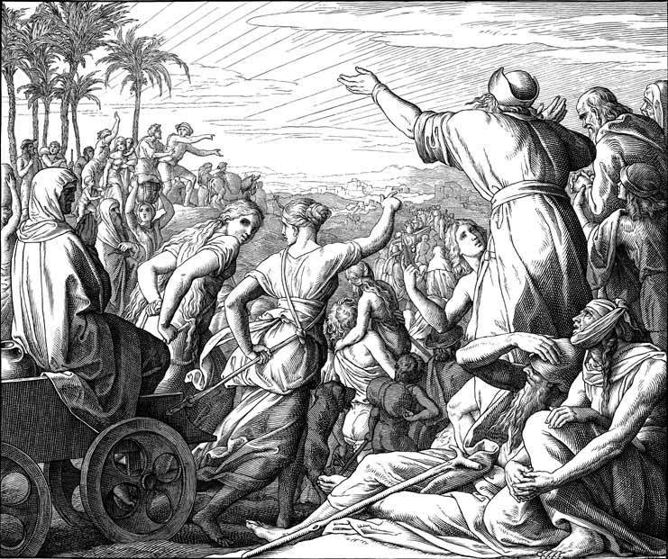
This is the word of Cyrus king of Persia: The Lord the God of heaven has given me all the kingdoms of the earth, and he himself has charged me to build him a house (temple) at Jerusalem in Judah. To every man of his people now among you I say, God be with him, and let him go up to Jerusalem in Judah, and rebuild the house (temple) of the Lord the God of Israel, the God whose city is Jerusalem.
Ezra 1: 2-3 (Hebrew Bible)
VOCABULARY:
Judah: The southern kingdom of the ancient Hebrews in Canaan. Jerusalem was its capital.

HISTORICAL SOURCE #2
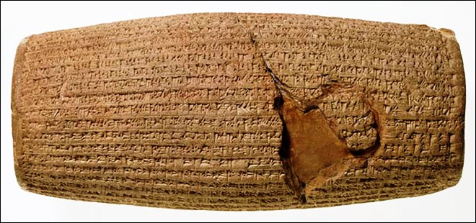
The Cyrus Cylinder is an ancient clay cylinder on which is written a declaration in the name of the Cyrus the Great. It dates from the 6th century BCE and was discovered in the ruins of Babylon in Mesopotamia (modern Iraq) in 1879. It was placed in the foundations of a building, probably a temple, following the Persian conquest of Babylon in 539 BC, when the Neo-Babylonian Empire was invaded by Cyrus and incorporated into his Persian Empire.
The following text is an extract from the Cyrus Cylinder.
20. I am Cyrus, king of the universe, the great king, the powerful king, king of Babylon, king of Sumer and Akkad, king of the four quarters of the world…
24. My vast troops were marching peaceably in Babylon, and the whole of Sumer and Akkad had nothing to fear.
25. I sought the safety of the city of Babylon and all its sanctuaries. As for the population of Babylon who have endured pain and suffering…
26. I soothed their weariness; I freed them from their bonds. Marduk, the great lord, rejoiced at my good deeds,
27. And he pronounced a sweet blessing over me, Cyrus, the king who fears him, and over Cambyses, my son, and over all my troops,
28. that we might live happily in his presence, in well-being. At his high command, all kings who sit on thrones,
29. From every quarter, from the Upper Sea to the Lower Sea, those who inhabit remote districts (and) the kings of the land of Amurru who live in tents, all of them,
30. Brought their weighty tribute into Shuanna, and kissed my feet. From Shuanna I sent back to their places to the city of Ashur and Susa,
31. Akkad, the land of Eshnunna, the city of Zamban, the city of Meturnu, Der, as far as the border of the land of Guti - the sanctuaries across the river Tigris - whose shrines had earlier become dilapidated,
32. The gods who lived therein, and made permanent sanctuaries for them. I collected together all of their people and returned them to their settlements,
VOCABULARY:
Marduk: The chief god of the city of Babylon.
Tribute: Payment made by one state or ruler to another as a sign of dependence
Shrine: A place regarded as holy, and is used for religious worship.
Sanctuary: A place of safety.

HISTORICAL SOURCE #3
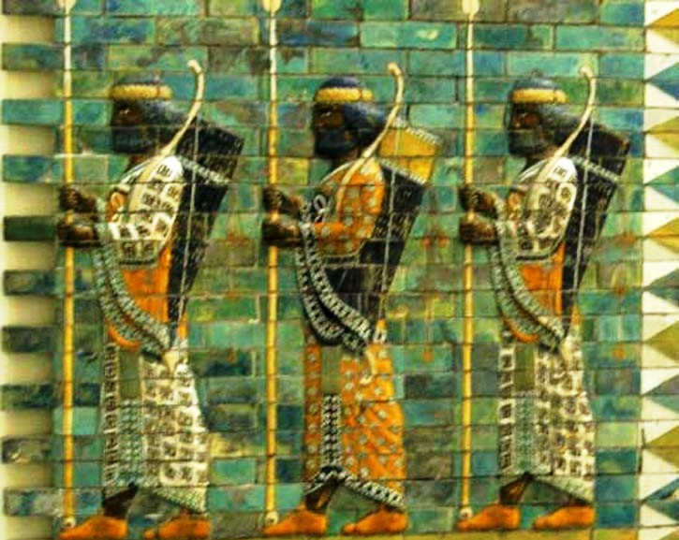
The following account is from The Histories, written by ancient Greek historian Herodotus from the 450’s to the 420’s BCE. The Histories serves as a record of the ancient traditions, politics, and geography of cultures that were known around the Mediterranean and Western Asia at that time. It stands as one of the first, and surviving, accounts of the rise of the Persian Empire.
Cyrus on his way to Babylon came to the banks of the Gyndes, which, rising in the Matienian mountains, empties itself into the river Tigris. When Cyrus reached this river, which could only be crossed in boats, one of the sacred white horses accompanying his march walked into the water, and tried to cross by himself; but the current seized him, swept him along with it, and drowned him in its depths. Cyrus, enraged at the rudeness of the river, threatened so to break its strength that in future even women should cross it easily without wetting their knees. Accordingly he put off for a time his attack on Babylon, and, dividing his army into two parts, he marked out by ropes one hundred and eighty trenches on each side of the river, leading off from it in all directions, and setting his army to dig, some on one side of the river, some on the other, and so reduced the strength of the river, but not without losing thereby the whole summer season.
(1.190) Having, however, thus taken his vengeance on the Gyndes river, by dispersing it through three hundred and sixty channels, Cyrus marched forward against Babylon. The Babylonians, camped outside their walls, awaited his coming. A battle was fought at a short distance from the city, in which the Babylonians were defeated by the Persian king, whereupon they withdrew within their city walls. Here they shut themselves up, and prepared for a siege, having laid in a store of provisions for many years in preparation against this attack; for when they saw Cyrus conquering nation after nation, they were convinced that he would never stop, and that their turn would come at last. Herodotus, Histories 1.189-191
VOCABULARY:
Babylon: A powerful city-state in ancient Mesopotamia.
Siege: A military operation in which enemy forces surround a town or building, cutting off essential supplies, with the aim of compelling the surrender of those inside.

