 | Name: | Student #:
 | Date: | Homeroom:

TEAM MEMBERS:

_________________________________________________________________________

START TIME: ______________________

END TIME: ________________________

Challenge 1: Geography of Canaan

1) Label the following landforms/bodies of water on the map below:
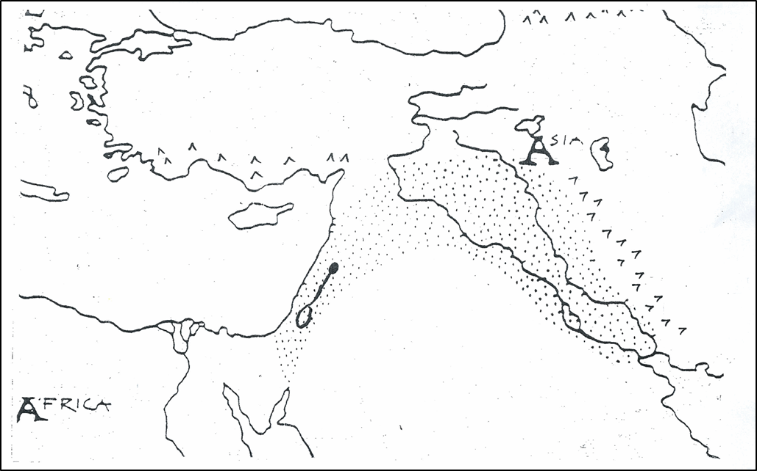
-Mediterranean Sea -Jordon River -Sinai Peninsula -Asia Minor

2) Create a key to label where the following regions are on the map above:
-Egypt -Phoenicia -Canaan -Hittite Empire -Mesopotamia

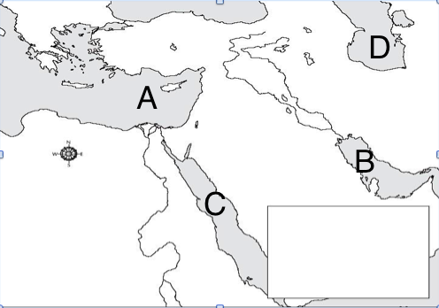
3) Which letter is over the Mediterranean Sea on the map to the left?
______________________

4) Which letter is over the Red Sea on the map to the left?
_______________________

Challenge 2: Prophets & Abraham

Who were the prophets?
The Israelites believed that God sent prophets, or messengers to share God’s word with people. The prophets told the Israelites that their God created the world and ruled over the world. The prophets of the Israelites told them that God is very powerful, but he is also just, fair and good. The prophets wanted the Israelites to understand that god expects goodness from his people.

5) What were prophets?  a. messengers from God  b. priests of Judaism  c. soldiers of Israel  d. rulers from Canaan | 6) Which of the following traits did the Israelites believe their God possessed?  a. fair  b. powerful  c. good  d. all of the above

Abraham
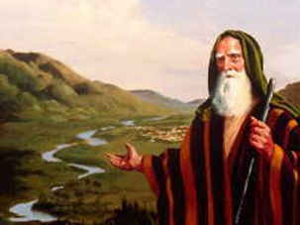
According to Jewish belief the ancestors of the ancient Israelites were a man named Abraham and his family. The Hebrew Bible gives this account of Abraham’s family and the early history of the Israelites. The Hebrew Bible states that God told Abraham to journey from Mesopotamia to Canaan. God promised Abraham that the land of Canaan would belong to Abraham and his descendants forever. Abraham and his wife Sarah accepted God’s promise and settled in Canaan. The land is often called the Promised Land because of God’s promise to Abraham.
After Abraham died, his son Isaac and later his grandson Jacob headed the family. Jacob has 12 sons that became the leaders of tribes or separate family groups. There were twelve tribes of Israel, each tribe was headed by one of Jacob’s sons.

7) Followers of the Jewish faith believe Abraham moved his family from ________________ to __________________.

8) Why do the Israelites call Canaan the “Promised Land”?
Claim
Evidence

Challenge 3: Moses and the Ten Commandments
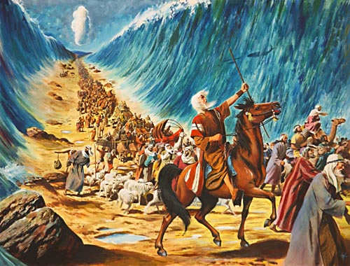
Moses went before the Pharaoh to demand the release of the Israelites. When the Pharaoh refused, God sent 10 plagues to Egypt. These plagues were events that caused problems for the Egyptians, such as locusts devouring the fields or outbreaks of diseases. The plagues convinced the Pharaoh to free the Israelites. The Israelites left Egypt; determined to return to their Promise Land of Canaan. After the Israelites left, the Pharaoh changed his mind. He sent his army after the Israelites.
When the Israelites reached the Red Sea, there was no way to cross the waters. According to the Hebrew Bible, God parted the Red Sea to let his people cross to the other side. When the Pharaoh’s army tried to follow the waters flooded back and drowned them. The departure of the Israelites out of slavery in Egypt is known as the Exodus. Jews celebrate a holy festival called Passover to remember their freedom from slavery.
Moses led the Israelites to Mount Sinai where according to the Hebrew Bible, the Israelites received a covenant or agreement with God. In the agreement, God promised to return the Israelites safely to Canaan if they promised to follow God’s teachings. Moses climbed to the top of Mount Sinai. On the top of Mount Sinai God gave Moses the Ten Commandments.

9) Moses and the Pharaoh argued over whether or not the __________________ would be released from slavery. | 10) Exodus is a term used to describe the…  a. successful revolt of Maccabeus  b. departure of Hebrews from Egypt  c. construction of the first temple  d. parting of the Red Sea | 11) Moses was believed to have made a _______________, or agreement with God.

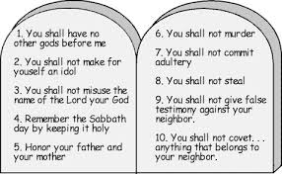
12) Which of the commandments to the left banned the Israelites from polytheism?
__________________________
__________________________
__________________________
__________________________

Challenge 4: What do Jews believe?

The Israelites practiced monotheism, this means they believed in one god. The Israelites had a specific set of rules that they had to follow. These rules, they believed, came from god and were called the Ten Commandments.
According to the Israelite religion, each person could have a personal relationship with god. They didn’t need a priest to do that for them. Instead, each person had to pray, study the Torah and do good acts to interact with God. The holy book that the Israelites believed in is called the Torah.
The Jews celebrate Passover to honor the memory of the Jews who were saved from the last plague in Egypt, when the Holy Spirit killed the first born unless there was lambs blood on the door frame. Jews also celebrate Hanukah to honor the Maccabeus who retook and cleansed the temple after the Greeks tried to place idols inside.
Jews also have a kosher diet. Which means they do not eat pork and only eat clean meat that has been prepared to specific standards. Jews also do not mix diary and meat. Jews celebrate the Sabbath from sundown Friday to sundown Saturday.

13) Which of the following terms mean “belief in one god”?  a. Hanukah  b. kosher  c. Sabbath  d. monotheism | 14) Which holiday celebrates the successful revolt of the Maccabees against the Greeks?  a. Passover  b. Hanukah  c. Sabbath  d. Easter
15) Which of the following is a holy book in Judaism?  a. the Torah  b. the Quran  c. the Vedas  d. the Sabbath | 16) Jews today have a ______________ diet; meaning they won’t eat pork or meat not prepared in a certain way.

17) How can one communicate with God according to the Israelite faith?
Claim
Evidence

Challenge 5: The Major Kings of Israel

18) Who did the Israelites have to defeat in order to live in Canaan?  - Phoenicians  - Philistines  - Israelites  - Egyptians  19) Why did the Israelites demand a king?  - they wanted to unite with the Philistines to take over Canaan  - they wanted to unite the 12 tribes to defeat the Philistines  - they wanted to be told how to live and what to do  - they wanted to pay high taxes and enslave them  20) Who chose the first king of Israel?  - Saul  - Solomon  - David  - Goliath | 21) The city of Jerusalem was made the capital by  - King Samuel  - King Solomon  - King Saul  - King David  22) The first temple in Jerusalem was built by  - King Samuel  - King Solomon  - King Saul  - King David  23) The Israelites turned against Solomon because  - Solomon was defeated by Goliath  - Solomon disobeyed God’s rules  - Solomon brought a long period of war  - Solomon’s building projects weren’t popular

King David’s son Solomon became the next Israelite King. Through trade deals and peace treaties with other people, Solomon brought a long period of peace to the region. Solomon constructed many cities and, according to the Hebrew Bible, built the first temple in Jerusalem.
Despite King Solomon’s accomplishments many Israelites turned against him. They did not like working on his building projects or paying the high taxes he demanded. After Solomon’s death the Israelites entered a troubled period in their history. Deep disagreements split their kingdom. In addition, powerful neighbors threatened their survival.

24) Underline evidence in the text above that explains why Israelites turned against Solomon.

Challenge 6: Canaan under Different Empires

After King Solomon died, the Israelites split into two kingdoms Israel and Judah. Israel was taken over by the Assyrians when the culture mixed they created the Samaritans.
In Judah, the Chaldeans took over and exiled thousands of Jews to Babylon. This was called the Babylonian Exile. But then the Persians took over and King Cyrus II let the Jews back to Judah. After the Persians were taken over by Alexander the Great the Ancient Greeks were in charge. The Greeks angered the Jews when they tried to place Greek gods inside the temple and force Jews to worship Greek gods. Judas Maccabeus created a small rebel army to take back Jerusalem. For a while the Jews were left alone. But then the Roman Empire came to power. They took over Jerusalem. The Jews began to disagree about how to deal with the Romans. The Zealots wanted to fight back. When they rebelled the Romans took revenge. They kicked out the Jews from Jerusalem and renamed Judaea into Palestine.

25) After Solomon died the Israelite kingdom
- united in one strong kingdom
- broke into 12 tribes
- split into 2 kingdoms
- fell apart

26) The new culture that was created from the Assyrians and Israelites were called the
a) Greeks b) Samaritans c) Romans d) Chaldeans

27) Use the box to fill in the blanks below

Romans Chaldeans Persians Palestine Greek

First the Israelites of Judah were taken over by King Nebuchadnezzar and the __________________. Then King Cyrus II and the ___________________ took over. They allowed the Jews to return to Judah. After that Alexander the Great used _____________culture to take over Judah. Finally the ___________________ took over and renamed it ___________________________.

28) Which two empires destroyed the temple when they took Jerusalem?
a. Assyrians and Chaldeans
b. Chaldeans and Romans
c. Romans and Greeks
d. Greeks and Assyrians

Challenge 8: Vocabulary

1____Torah  2_____Covenant  3____Monotheism  4____Canaan  5____Exodus  6_____Plagues  7____10 commandments  8____Tabernacle  9_____Diaspora  10_____Kosher  11_____Synagogue  12_____Sabbath  13_____prophet  14_____Palestine | - The departure of the Israelites out of slavery  - The belief in one god  - Romans renamed Judaea to this name  - One important part of the Torah, rules for Israelites to live by  - Agreement with god  - Teachings from God Moses received at the top of Mount Sinai  - Jewish houses of worship  - Lasts from sundown Friday to sundown Saturday  - Food according to Jewish dietary law  - Messengers from god  - Israelites at one point worshipped in a large tent like structure  - Events that caused problems for the Egyptians  - Jews living outside the Jewish homeland  - Promised Land

Challenge 9: Time Lines

Place the following events in chronological order on the timeline below:
A - 71 CE (More Jews live in the Diaspora than in Canaan)
B - 1312 BCE (Exodus from Egypt)
C - 879 BCE (Saul anointed king)
D - 422 BCE (Babylonian Exile begins)
E - 63 BCE (Roman’s take Canaan)
F- 1812 BCE (Time of Abraham)
G -70 CE (Roman’s destroy the second temple)
H - 825 BCE (King Solomon’s Temple constructed)

