Name: Student #:
Date: HR:

Do Now

- The Promise Land is  - Egypt  - Mesopotamia  - Canaan  - India  - The first prophet of the Israelites was _____________________  a) Moses b) Saul c) Abraham d) Solomon  - Who built the first temple in Jerusalem?  a) Moses b) Saul c) David d) Solomon | 4) The Israelites at one point worshipped in a tent called a  a) temple b) synagogue c) tabernacle d) church  5) After the death of Solomon the Kingdom of Israel  - united the 12 tribes and became strong  - broke into two kingdoms  - stopped practicing monotheism  - established Christianity  6) Who controlled the Mediterranean Sea, and all its trading, at one point in history?  a) Philistines b) Israelites c) Phoenicians d) Assyrians

Lesson Information

Title: Chaldean Rule & the Babylonian Exile

Objective: I can write a journal entry as if I was an Israelite during the Babylonian Exile to demonstrate an understanding of the event.

Guiding Question: How did the Chaldean Empire impact the ancient Israelites?

Agenda:
1) Text Analysis
2) Musical Connection
3) Journal Entries
4) Exit Ticket

Update on Assyrian Empire
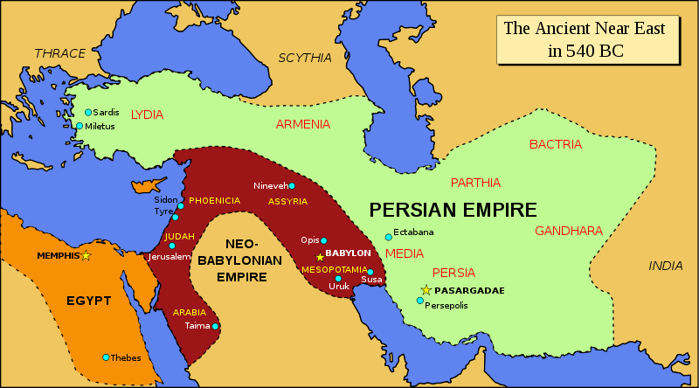
The Assyrian Empire is eventually destroyed by the rising Persian and Chaldean (or Neo-Babylonian) Empires. By this time the 10 tribes that were moved by the Assyrians have all but vanished. Judah remains as the only remnant of the Kingdom of Israel.
Why did Judah fall?
Now, only the small kingdom of Judah was left of the once proud empire of David. It did not last long, because the Egyptians conquered it around 620 BCE. The Jews were able to keep their king but paid tribute to Egypt.
However, Egyptian rule was cut short when Chaldeans conquered Egypt in 605 BCE. The Chaldeans treated the Israelites like the Egyptians had before. They allowed the Jews to keep their king as long as they paid tribute.
Several years later, the Jews united with the Egyptians to rebel against the Chaldeans. Judah held out against the Chaldean invasion until 597 BCE. That year, King Nebuchadnezzar (NEH byuh kuhd NEH zuhr) of the Chaldeans captured Jerusalem. He punished the Jews severely. He made 10,000 Jews leave the city and live in Babylon, the Chaldean capital. Then he appointed a new Jewish king.
1) How did both the Egyptians and Chaldeans treat the kingdom of Judah?
Claim
Evidence

The Babylonian Exile
The people of Judah survived the Assyrian conquests but their freedom did not last. In 597 BC the Chaldeans, under King Nebuchadnezzar, forced thousands of people to leave Jerusalem and live in Babylon, the Chaldean capital. Nebuchadnezzar chose a new king for Judah.
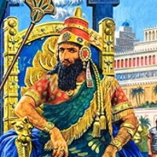
At first Judah’s king did as he was told. Soon, however, he plotted to set Judah free. A prophet named Jeremiah warned that God did not want Judah to rebel but the king refused to listen. The King led the people of Judah to a successful revolt. The Chaldeans retook Jerusalem in 586 BC. Nebuchadnezzar then destroyed Jerusalem to the ground. He destroyed the temple, captured the king and took him thousands of Judah’s people to Babylon.
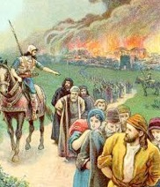
In Jewish history this time became known as the Babylonian Exile. When people are exiled they are forced to leave their home or country. Psalm 137, in the Hebrew Bible, describes the sadness many of Judah’s people felt living so far away from their homeland.
“By the rivers of Babylon we sat and we wept…How can we worship our God when we are in a foreign land.”
The families of the Judeans who were exiled to Babylon spent 70 years away from Judah. During their exile, they became known as the Jews. We call their religion Judaism. While in Babylon, in exile the Jews no longer had a temple where they could worship god. It is believed that small groups of Jews began to meet a synagogues, or Jewish houses of worship. They worshipped on the Sabbath. The Sabbath lasts from sundown Friday to nightfall Saturday. On this Sabbath Jews prayed and talked about their religion and history. Jews still observe the Sabbath day.
2) How did Nebuchadnezzar respond the successful revolt in Judah?
Claim
Evidence

3) During their time in Babylon the exiled Judeans became known as_________________.
4) Which of the following serves as a primary source for this history?
a. the Torah b. the Hebrew Bible c. the Quran d. the Vedas

Rivers of Babylon
By Sublime

By the rivers of Babylon
Where he sat down
And there he wept when he remembered Zion.

Oh from wicked, carry us away from captivity
Required from us a song
How can we sing King Alpha's song in a strange land?

So let the words of our mouth
And the meditations of our hearts
Be acceptable in thy sight
O-verride

By the rivers of Babylon
Where he sat down
And there he wept when he remembered Zion.

Oh from wicked, carry us away from captivity
Required from us a song
How can we sing King Alpha's song in a strange land?
How can we sing King Alpha's song in a strange land?

5) When the artist says “Zion” he is referring to the land of _________________________.

6) One day you will hear this song on the radio and, luck for you, you will have the knowledge to explain what this song is referring to. In the space below, explain which historic event this song is referring to.
________________________________________________________________________________________________________________________________________________________________________________________________________________________________________________________________________________________________________________________________________________________________________________________________________________________________________________________________________________________________________________________________________

7) This style of music is called ‘reggae’ and has roots in Africa and the Caribbean. The fact that they are singing about Babylon makes this song an example of cultural __________________.

Journal Entries

Pretend you are an Israelite living in the kingdom of Judah during the 500’s BCE. You are to write two separate journal entries.
-Entry one: The Chaldeans have returned to retake Jerusalem after the successful revolt in Judah.
-Entry two: The Jews are now being held in Babylon.
You must use and define 4 of the following terms in your entries:
Nebuchadnezzar Jews exile Babylon temple Judah
Chaldean Empire synagogue Jeremiah Sabbath

Entry One: The Chaldeans Are Retaking Jerusalem!
________________________________________________________________________________________________________________________________________________________________________________________________________________________________________________________________________________________________________________________________________________________________________________________________________________________________________________________________________________________________________________________________________
________________________________________________________________________________________________________________________________________________________________________________________________________________________________________________________________________________________________________________________________________________________________________________________________________________________________________________________________________________________________________________________________________
________________________________________________________________________________________________________________________________________________________________________________________________________________________________________________________________________________________________________________________________________________________________________________________________________________________________________________________________________________________________________________________________________
________________________________________________________________________________________________________________________________________________________________________________________________________________________________________________________________________________________________________________________________________________________________________________________________________________________________________________________________________________________________________________________________________

Entry 2: We Are Now in Babylon…
________________________________________________________________________________________________________________________________________________________________________________________________________________________________________________________________________________________________________________________________________________________________________________________________________________________________________________________________________________________________________________________________________
________________________________________________________________________________________________________________________________________________________________________________________________________________________________________________________________________________________________________________________________________________________________________________________________________________________________________________________________________________________________________________________________________
________________________________________________________________________________________________________________________________________________________________________________________________________________________________________________________________________________________________________________________________________________________________________________________________________________________________________________________________________________________________________________________________________
________________________________________________________________________________________________________________________________________________________________________________________________________________________________________________________________________________________________________________________________________________________________________________________________________________________________________________________________________________________________________________________________________
________________________________________________________________________________________________________________________________________________________________________________________________________________________________________________________________________________________________________________________________________________________________________________________________________________________________________________________________________________________________________________________________________

Name: Student #:
Date: HR:

- King Nebuchadnezzar
- converted to the Israelite religion and ruled in Judah
- took over Judah and forced the people to relocate to Babylon
- took over Israel and Judah
- took over Judah and forced the people to convert back to polytheism

- What best describes an “exile”?
- an exile is when people are forced to convert to a different religion
- an exile is when people are forced to leave their home or country
- an exile is when people forcibly take over a new area of land by making their homes in the new land
- an exile is an ancient monotheistic religion

- During the Babylonian Exile the Judeans became known as ___________________________.

- While in exile the place of worship was called a
- tabernacle
- church
- synagogue
- temple

- The Jews worship on the _________________________
- Sunday
- Saturday
- Sabbath
- Weekday

