Name: Student #:
Date: HR:

Do Now

- King Nebuchadnezzar  - converted to the Israelite religion and ruled in Judah  - took over Judah and forced the people to relocate to Babylon  - took over Israel and Judah  - took over Judah and forced the people to convert back to polytheism  - What best describes an “exile”?  - an exile is when people are forced to convert to a different religion  - an exile is when people are forced to leave their home or country  - an exile is when people forcibly take over a new area of land by making their homes in the new land  - an exile is an ancient monotheistic religion  - During the Babylonian Exile the Judeans became known as ___________________________. | - While in exile the place of worship was called a  - tabernacle  - church  - synagogue  - temple  - The Jews worship on the _________________________  - Sunday  - Saturday  - Sabbath  - Weekday  6) Write your own definition of “monotheism”.  _______________________________________________  _______________________________________________  _______________________________________________  _______________________________________________  _______________________________________________

Lesson Information

Title: Judah under the Romans and Greeks

Objective: I can analyze texts and images to answer questions relating to the kingdom of Judah under the Greeks and Romans.

Guiding Question: How did the kingdom of Judah change under the Greeks and Romans?

Agenda:
1) Jews Return to Judah
2) Judah under the Greeks
3) Judah under the Romans
4) Exit Ticket

The Jews Return to Judah

During the 500s BCE, a group of people called Persians swept across southwest Asia. The Persians defeated the Chaldeans and took over Babylon. In 583 BCE the Persian king Cyrus permitted Jews return to Judah.
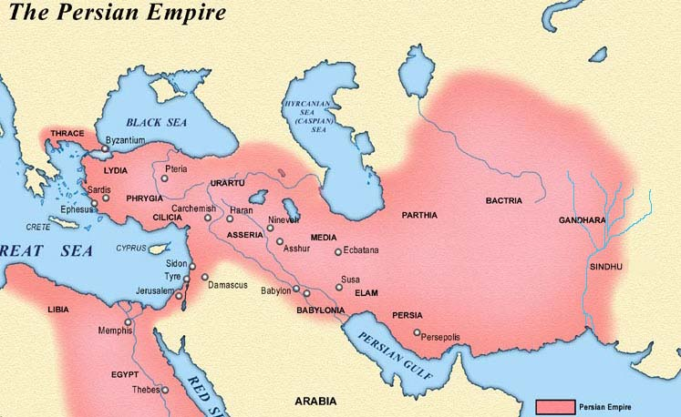
Some Jews stayed in Babylon, but many went home. They rebuilt Jerusalem and the temple. Cyrus appointed officials to rule the country and collected taxes from the people. The Persians did not allow the Jews to have an independent government or king, so the Jews depended mainly on their religious leaders – not temple priests and scribes – to run their society.

1) Circle the city of Jerusalem on the map above.

2) The ____________________ king named __________________ let the Jews return to Judah.

3) How did Cyrus govern the country of Judah?
Claim
Evidence

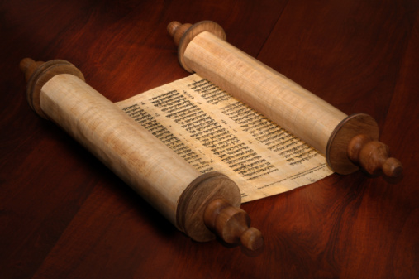
Many scribes became religious scholars. Under a scribe named Ezra, the Jews wrote the five books of the Torah on pieces of parchment. They sewed the pieces together to make long scrolls. The Torah and writings that were added later made up the Hebrew Bible.
The Hebrew Bible is really a series of books collected together. The Torah, the Prophets, and the Writings that were added later make up the Hebrew Bible. Some of these books describe events in Jewish history. Others are books of law, prophecy, poetry, and proverbs.

4) Which of the following topics is not covered by one of the books in the Hebrew Bible?
a. law for creating order
b. Jewish history
c. proverbs for advice
d. none of the above

5) Which of the following made up the Hebrew Bible
a. the Prophets
b. the Torah
c. the Writings
d. all of the above

6) Is the Hebrew Bible considered a primary source for Jewish history? Justify your answer!
________________________________________________________________________________________________________________________________________________________________________________________________________________________________________________________________________________________________________________________________________________________________________________________________________________________________

The Jews and the Greeks

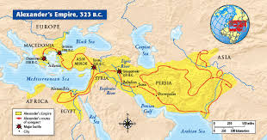
In 334 BCE, a king named Alexander the Great set out to conquer kingdoms in western Asia. In 331 BCE his armies defeated the Persians, so Judah came under his control. Fortunately, Alexander allowed the Jews to stay in Judah. However, Alexander, who loved all things Greek, introduced the Greek language and Greek ways to Judah. The Greek language was then used to spread Jewish ideas around the Mediterranean World.
At the time, Jews were living throughout Alexander’s empire. Many still lived in Babylon. Some lived in Egypt and other lands bordering the Mediterranean Sea. The scattering of the Jews outside of Israel and Judah became known as the Diaspora (dy AS pruh). Diaspora is a Greek word that means “scattered”.

7) How did Judah fall under the control of Alexander?
Claim
Evidence

8) Underline evidence in the text that supports this idea: The Greek language encouraged the cultural diffusion of the Jewish culture.

9) What does “diaspora” mean?
________________________________________________________________________________________________________________________________________________________________________________________________________________________________________________________________________________________________________________________
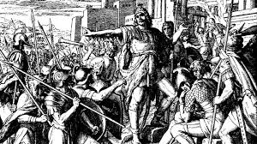
In 168 BCE a Greek ruler named Antiochus controlled Judah. He decided to make the Jews of Judah worship Greek gods and goddesses. A priest named Judas Maccabeus and his followers rebelled. They fled to the hills and formed an army known as the Maccabees.
After many battles, the Maccabees drove the Greeks out of Judah. They destroyed all traces of Greek gods and goddesses in their temple and rededicated it to the worship of God. Each year the Jews recall the cleansing of the temple when they celebrate Hanukkah.
Priests from Judas Maccabeus’ family became the new rulers of Judah. Under their leadership, Judah took over land that had been part of the kingdom of Israel.

10) Why did Maccabeus decide to lead a rebellion against the Greeks?
Claim
Evidence

11) The land belonging to which former kingdom was added to the Kingdom of Judah after Maccabeus’ rebellion?
a. Israel
b. Judah
c. Phoenicia
d. Palestine

The Jews and the Romans

In 63 BCE, a people known as the Romans conquered Judah. Led by powerful generals, the Romans were intent on expanding their empire. The Roman capital was far to the west of what is today the country of Italy. When the Romans conquered Judah, they renamed in Judaea. At first they allowed Jewish rulers to rule Judaea but later appointed Roman governors as rulers.
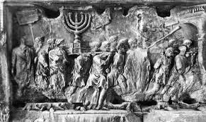
During the 60’s CE, Jewish hatred of Roman rule was at its peak. Many Jews were waiting for a messiah, or deliverer sent by God. Other Jews known as Zealots wanted to fight the Romans for their freedom.
In 66 CE the Zealots revolted against the Romans and drove them out of Jerusalem. Four years later, the Romans retook Jerusalem. They killed thousands of Jews and forced many others to leave. The Romans also destroyed the temple in Jerusalem. The Western Wall is all that remains of it today.

12) After the Jews drove the Greeks out of Judah, a group of people known as the ___________________ came to dominate the region.

13) How did Rome respond to the Zealots revolt in 66 CE?

Claim
Evidence

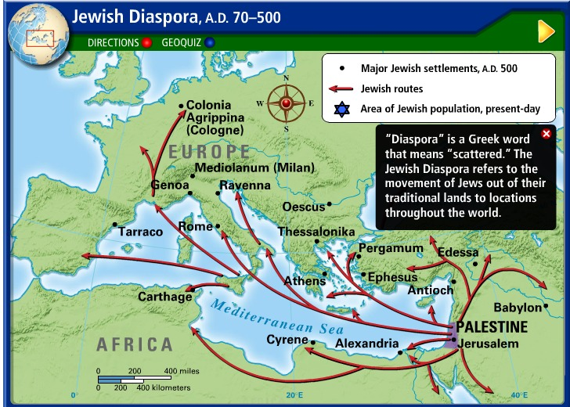
The Jews revolted again in 132 CE. Three years later, the Romans crushed the revolt. This time, the Romans forbade the Jews to live in or even visit Jerusalem. They began calling Judah by the name of Palestine. This name refers to the Philistines, whom the Israelites had conquered centuries before. The majority of Jews would live outside of Canaan for several centuries. The Greek word “diaspora” is used to describe the spread-out Jewish community.

14) What did the Jews do in 132 CE that led to the Romans banning the Jews from living in Jerusalem?

Claim
Evidence

15) The Romans began calling Judah by the name of _________________________ after banning the Jews from Jerusalem.

Name: Student #:
Date: HR:

Exit Ticket

1) Which Persian king allowed the Jews to return to Judah after years of being exiled in Babylon?
a. Xerxes
b. Cyrus the Great
c. Darius the Great
d. Nebuchadnezzar

2) Which group came to rule Judah after the Persians?
a. the Greeks
b. the Phoenicians
c. the Babylonians
d. the Philistines

3) Which group of people destroyed the rebuilt temple in Jerusalem following a Jewish rebellion in 70 CE?
a. the Greeks
b. the Persians
c. the Romans
d. the Babylonians

4) What name was given to the land of Judah during the Roman Empire?
a. Israel, to commemorate Abraham’s covenant with God
b. Judah, the name stayed the same
c. Palestine, in honor of the Philistines who once lived there
d. Phoenicia, the name that belonged to the largest trading empire at the time

5) The term ______________________________ refers to the scattering of the Jewish people outside of the land of Canaan.

