Name: Student #:
Date: HR:

Do Now

1) Flow into the room and find the desk with your name on it. (1 – Illinois, 2 – CBU, 3 – WCU, 4 – Tennessee)

2) Use the space below to tell me something about your winter break.
____________________________________________________________________________________________________________________________________________________________________________________________________________________________________________________________________________________________________________________________________________________________________________________________________________________________________________________________________________________________________________________________________________________________________________________________________________

3) Which of our core values do you intend on developing in yourself this semester? Explain your answer.
____________________________________________________________________________________________________________________________________________________________________________________________________________________________________________________________________________________________________________________________________________________________________________________________________________________________________________________________________________________________________________________________________________________________________________________________________________

Lesson Information

Title: The Geography of Ancient Israel

Objective: I can label the significant landforms and bodies of water that characterized the area around the ancient civilization of Israel.

Guiding Question: How did ancient Israel’s geographic location impact their civilization?

Agenda:
1) Updates in Procedures
2) Map Analysis
3) Ancient Israel’s Geography
4) Text Analysis
5) Exit Ticket

Updates in Procedures

A) The First Five Minutes of Class
1 – Enter silently, take a class packet off the desk, and follow the flow to your seat.
2 – You will have 5 minutes from the beginning off the period to silently and independently complete the Do Now.
3 – Silently choice read if you finish early.

B) The Last Five Minutes of Class
1 – I will indicate when we have five minutes left in class. You will clear your desk off everything but your Exit Ticket.
2 – You will have 5 minutes from when I stop class to silently and independently complete the exit ticket.
*From here on out, your desk must ALWAYS be clear when completing an Exit Ticket.
3 – Once you complete your exit ticket you will silently stand up and get your desk in proper position.
4 – You will then silently enter the flow, drop off your exit ticket, and line up.
5 – Choice read silently while in line.

C) Asking Questions
You will have five opportunities to ask questions in class.
1 – Silently raise your hand when working on independent practice.
2 – Silently raise your hand when working in pairs or groups AFTER you’ve asked your partner(s) your question first.
3 – Write a note on a piece of paper and leave it at the corner of your desk (I will silently answer this question at some point during the lesson.
4 – Place a note (with your name on it) in the question box when you flow out of class.
5 – Silently raise your hand at any point during the lesson when I ask, “I have time for # questions.”

D) Early Finishers
1 – If you finish independent practice early you will silently raise your hand.
2 – I will check your IP and allow you to clear your desk for your exit ticket.
3 – Once the exit ticket is done you may do one of the following:
a. Silently drop off your exit ticket and grab a News ELA article from the current events counter. If you get a 100% on the quiz attached to the reading I will award you a $3 bucket.
b. Silently choice read until the last 5 minutes of class timer starts.

Map Analysis

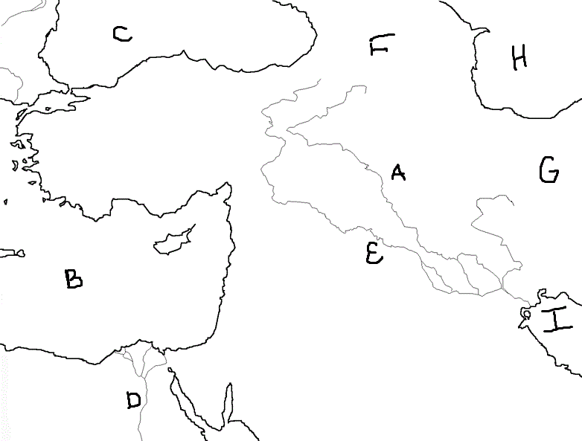
1) Which letter is over the Mediterranean Sea?
a. A
b. B
c. C
d. C

2) Which letter is over the Tigris River?
a. A
b. E
c. G
d. D

3) Which river is located by the D on the map?
_______________________________________

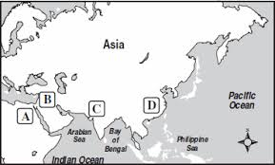
4) Which letter is over the Chinese civilization?
a. A
b. B
c. C
d. D

5) Which letter is over the Mesopotamian
civilization?
a. A
b. B
c. C
d. D

6) Which letter is over the Egyptian civilization?
a. A
b. B
c. C
d. D

7) Which type of geographic feature helped all of the ancient civilizations we’ve studied so far develop?
______________________________________________________________________________________________________________________________________________________________________________________________________________________________________________________________________________________________________

Ancient Israel’s Geography
Judaism
- The ______________________ were a group of people in Southwest Asia who unlike other cultures in the ancient times believed in one God. The belief in one God is called ______________________.
- The Israelites believed that God sent _______________________ or messengers to share God’s word with people. The prophets communicated to the Israelites that their God created and ruled the world. The prophets believed that every individual could ____________________ personally God through prayer, religious study, and good and just acts.
- The ancient Israelites struggled for centuries to build a ______________ homeland. This was difficult because their location in the eastern ________________________ region was surrounded by more powerful empires.
- Through the Hebrew bible the beliefs of ancient Israelites lived on to become the religion of _______________. Judaism became a world religion that would influence two other religions, __________________ and Islam.

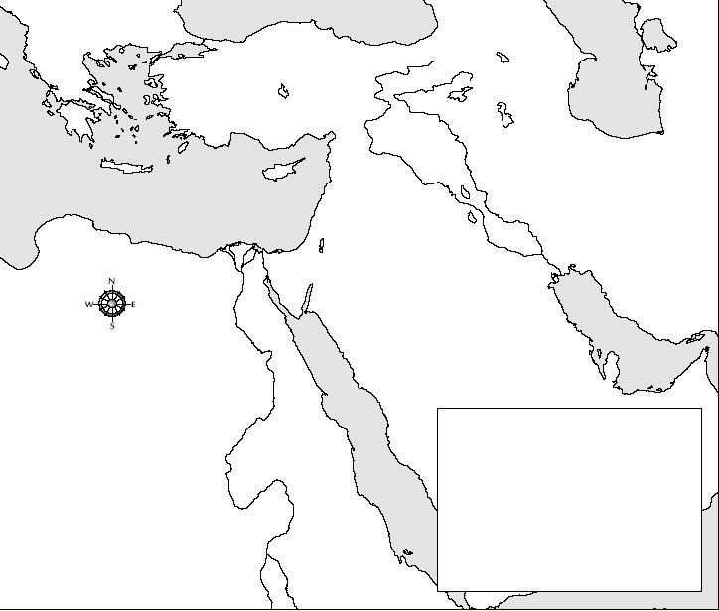
The ancient Israelites struggled for centuries to build a secure homeland. This was difficult because their location in the eastern Mediterranean region was surrounded by more powerful empires. Judaism became a world religion it would later influence two other religions, Christianity and Islam.

We’re going to label the following on the map above:
-Mediterranean Sea -Nile River -Red Sea -Egypt -Sinai Peninsula
-Mesopotamia -Canaan -Asia Minor

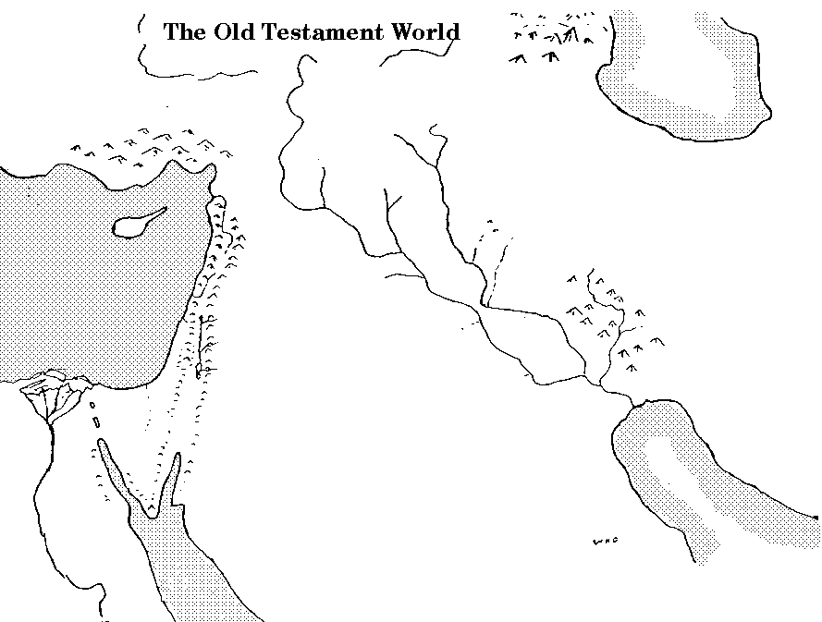
We’re going to label the following terms on the map above.

-Mediterranean Sea -Cannan -Mesopotamia -Red Sea -Asia Minor
-Egypt -Hittite Empire -Jordan River -Sinai Peninsula -Phoenician Empire

Text Analysis

-The beliefs and early leaders of the ancient Israelites represent the foundations of Judaism

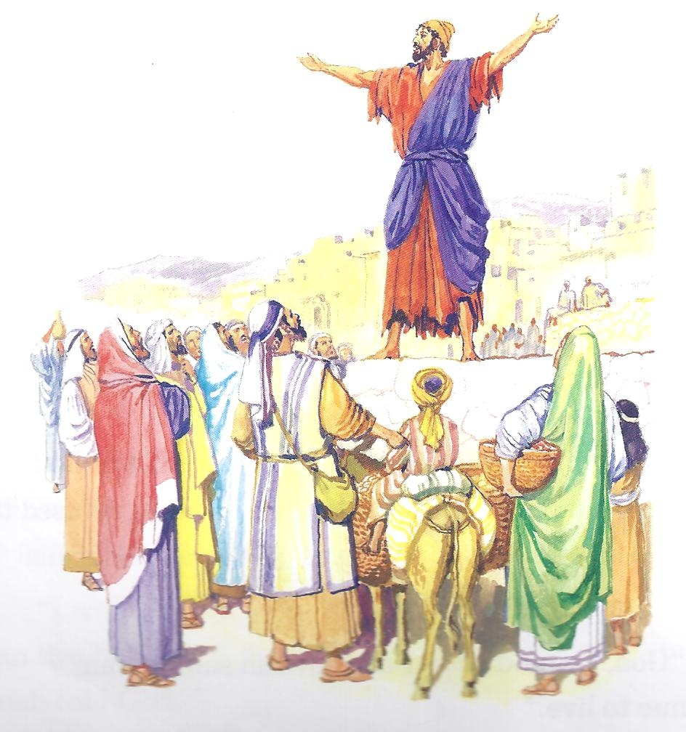
You have probably heard of the religion of Judaism. You may not know that this religion is both ancient and modern. Many ancient civilizations and societies worshipped many deities or gods. The worship of more then one god is called polytheism. But a group in southwest Asia known as the Israelites were different. Unlike other cultures of the day, they worshipped only one god. Worshipping one god is called Monotheism.
The Israelites believed that God sent prophets, or messengers to share God’s word with people. The prophets told the Israelites that their God created the world and ruled over the world. The prophets of the Israelites told them that God is very powerful, but he is also just, fair and good. The prophets wanted the Israelites to understand that god expects goodness from his people.

1. The Israelites were the first group in history to worship ___________god.

2.The belief in one god is called _____________________.

3) How did the Israelites believe God communicated with them?
Claim
Evidence

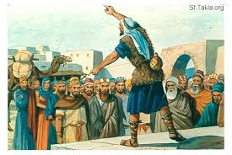
The prophets believed that every individual could connect personally to God through prayer, religious study and good and just acts. The practice of monotheism made Judaism unique among ancient religions. The Israelites recorded their beliefs and their own history in the Hebrew Bible. The Hebrew bible was preserved, saved and passed on throughout history and became the religion of Judaism. The followers of Judaism are today known as Jews.

Judaism was the first religion to practice monotheism, belief in one god. Judaism played an important part in the development of two other major monotheistic religions, Christianity and Islam. In fact, the Christian bible has an old and new testament. The Old Testament is the Hebrew bible. Christianity grew directly from Judaism. Islam accepted some of the teachings of Judaism.

- According to the Israelite prophets how could a person connect with God?
__________________________________________________________________________________________________________________________________
- The Israelites wrote down the history and beliefs in the ____________________Bible
- The Israelites eventually became the religion of ________________________.

Name: Student #:
Date: HR:

Exit Ticket
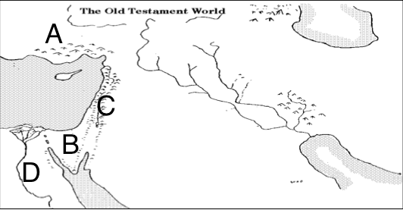

1) Which letter on the map above indicates the location of Sinai Peninsula?
a) A
b) B
c) C
d) D

2) Which letter on the map below indicates the location of Asia Minor?
a) A
b) B
c) C
d) D

3) Which letter on the map below indicates the location of Cannan?
a) A
b) B
c) C
d) D

4) Which letter on the map below indicates the location of Ancient Egypt?
a) A
b) B
C) C
D) D

