Name: Student #:
Date: HR:
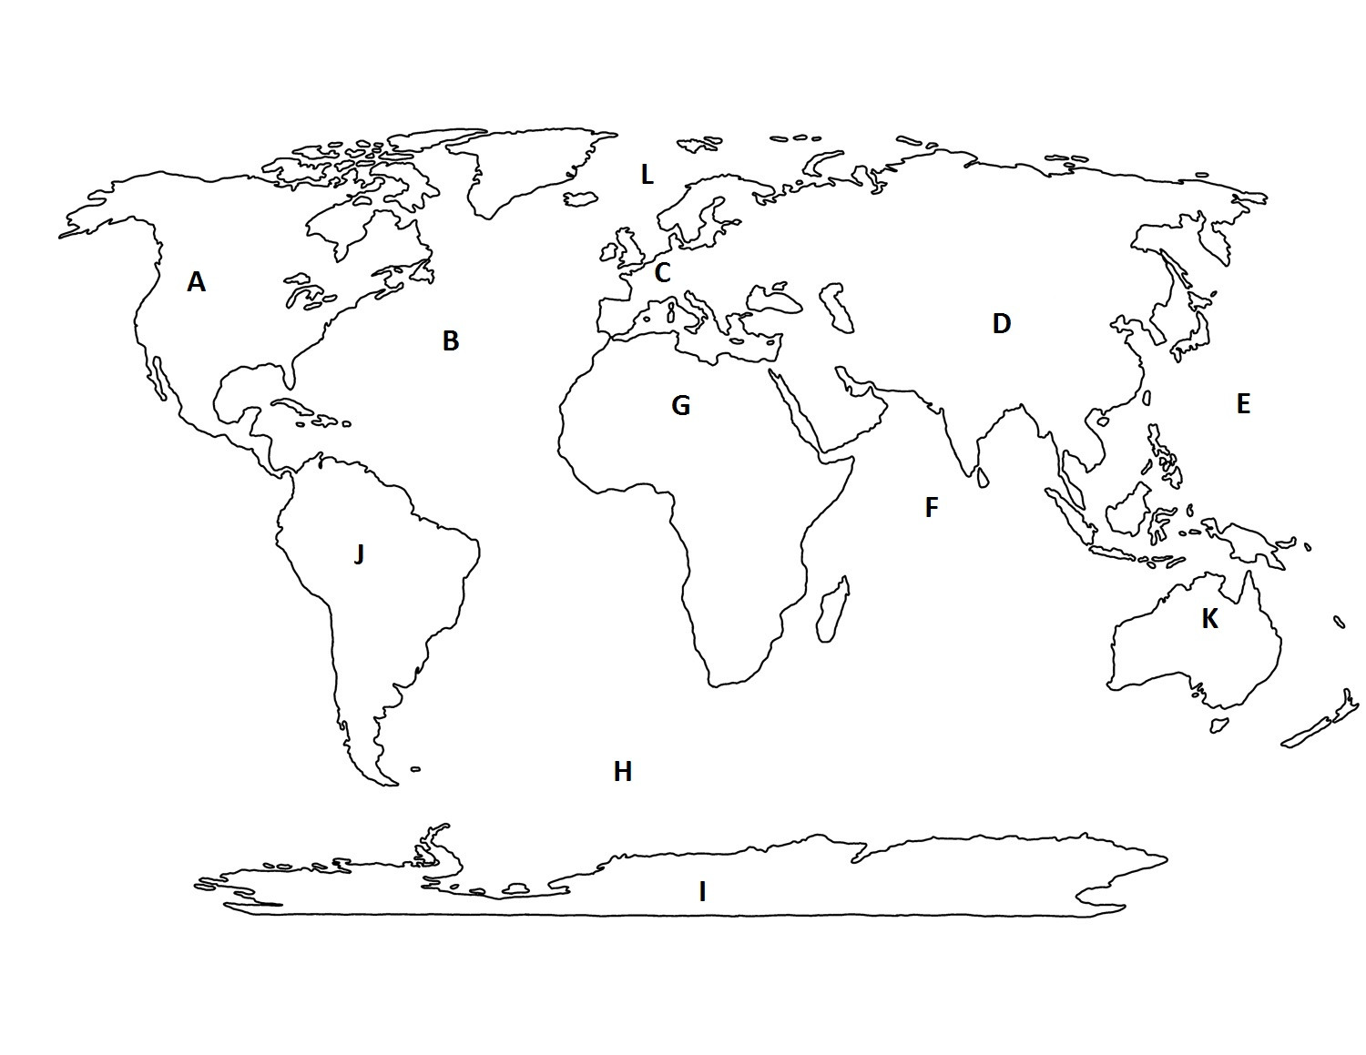
Do Now – World Geography Review

1) Which letter is over North America? | 2) Which letter is over the Pacific Ocean? | 3) Which letter is over Africa?
4) Which letter is over Europe? | 5) Which letter is over Asia? | 6) Which letter is over the Indian Ocean?

Lesson Information

Title: The Origins of the Israelites  Guiding Question: Who were the Israelites? | Objective: I can analyze maps and texts to answer questions about the origins of the Israelites. | Agenda:  1) Text Analysis  2) Map Review  3) Independent Practice  4) Exit Ticket
Text Analysis

-The beliefs and early leaders of the ancient Israelites represent the foundations of Judaism

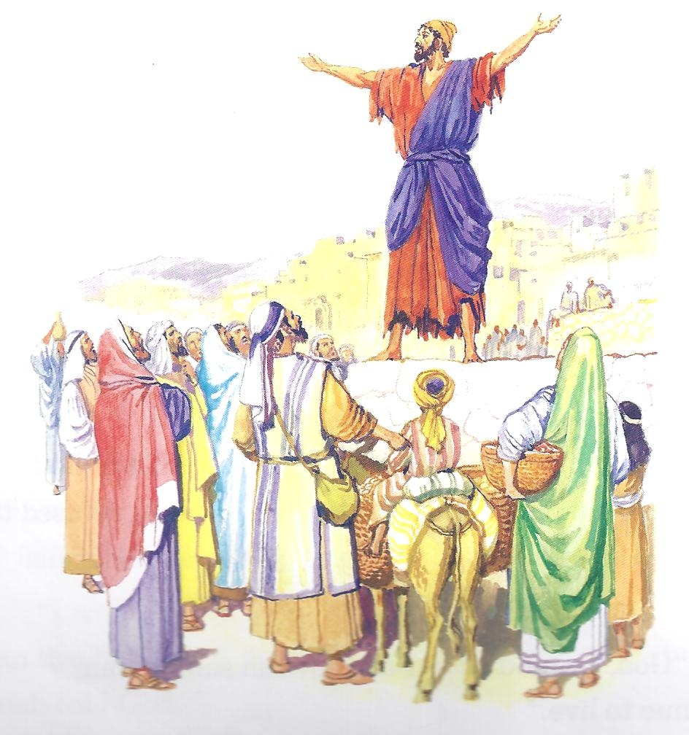
You have probably heard of the religion of Judaism. You may not know that this religion is both ancient and modern. Many ancient civilizations and societies worshipped many deities or gods. The worship of more than one god is called polytheism. But a group in southwest Asia known as the Israelites were different. Unlike other cultures of the day, they worshipped only one god. Worshipping one god is called Monotheism.
The Israelites believed that God sent prophets, or messengers to share God’s word with people. The prophets told the Israelites that their God created the world and ruled over the world. The prophets of the Israelites told them that God is very powerful, but he is also just, fair and good. The prophets wanted the Israelites to understand that god expects goodness from his people.

1. The Israelites were the first group in history to worship ___________god.

2.The belief in one god is called _____________________.

3) How did the Israelites believe God communicated with them?
Claim
Evidence

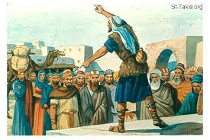
The prophets believed that every individual could connect personally to God through prayer, religious study and good and just acts. The practice of monotheism made Judaism unique among ancient religions. The Israelites recorded their beliefs and their own history in the Hebrew Bible. The Hebrew bible was preserved, saved and passed on throughout history and became the religion of Judaism. The followers of Judaism are today known as Jews.

Judaism was the first religion to practice monotheism, belief in one god. Judaism played an important part in the development of two other major monotheistic religions, Christianity and Islam. In fact, the Christian bible has an old and new testament. The Old Testament is the Hebrew bible. Christianity grew directly from Judaism. Islam accepted some of the teachings of Judaism.

- According to the Israelite prophets how could a person connect with God?
__________________________________________________________________________________________________________________________________
- The Israelites wrote down the history and beliefs in the ____________________Bible
- The Israelites eventually became the religion of ________________________.

Map Review!
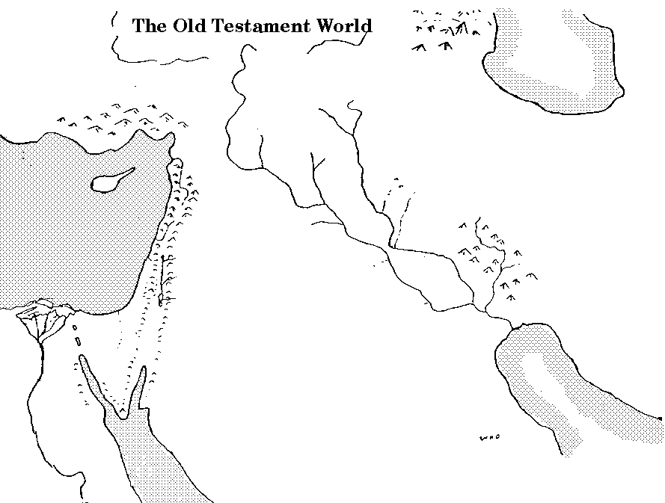
Label the following on the map above:
-Mediterranean Sea -Canaan -Mesopotamia -Red Sea -Asia Minor
-Egypt -Hittite Empire -Jordan River -Sinai Peninsula -Phoenician Empire

Quick Check for Understanding:

- Describe the difference between polytheism and monotheism.
________________________________________________________________________________________________________________________________________________________________________________________________________________________________________________________________________

- Which came first; Judaism or the Israelites?
________________________________________________________________________________________________________________________________________________________________________________________________________________________________________________________________________

- Which came first; Christianity or Judaism?
________________________________________________________________________________________________________________________________________________________________________________________________________________________________________________________________________

- What did the Israelites record in the Hebrew Bible?
________________________________________________________________________________________________________________________________________________________________________________________________________________________________________________________________________

- How do Christians use the Hebrew Bible?
________________________________________________________________________________________________________________________________________________________________________________________________________________________________________________________________________
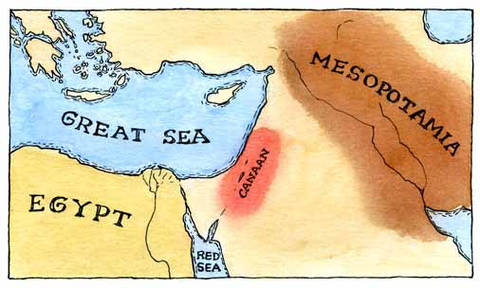
Israelites: Who are these people?

Around 1200 BC great changes took place in the Mediterranean region. Egypt’s empire ended and new peoples including the Israelites created kingdoms in the region. The early Israelites depended on herding and trading to survive. They moved a lot and so they didn’t settle farms. According to the Hebrew bible, Abraham and his family migrated from Mesopotamia and settled in Canaan, along the Mediterranean Sea.
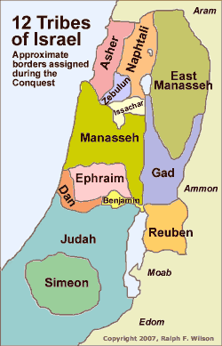
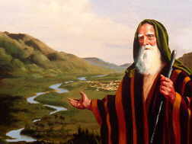
Abraham
According to Jewish belief the ancestors of the ancient Israelites were a man named Abraham and his family. The Hebrew Bible gives this account of Abraham’s family and the early history of the Israelites. The Hebrew Bible states that God told Abraham to journey to Canaan. God promised Abraham that the land of Canaan would belong to Abraham and his descendants forever. Abraham and his wife Sarah accepted God’s promise and settled in Canaan. The land is often called the Promise Land because of God’s promise to Abraham.

Keeping it in the Family
After Abraham died, his son Isaac and later his grandson Jacob headed the family. Jacob has 12 sons that became the leaders of tribes or separate family groups. There were twelve tribes of Israel, each tribe was headed by one of Jacob’s sons.

After living in Canaan for many years Jacob’s family left because of a famine. They migrated to Egypt and lived there in peace for several generations. As the Israelite population increased however, the Egyptian pharaoh grew uneasy. He feared that one day the Israelites would rebel. To prevent this, the Egyptians reduced the Israelites to slavery.

Use the text above to answer the questions on this page and the next page.

1) How did the Israelites survive?  - they farmed and had complex irrigation systems  - they traded and herded animals  - they were skilled artisans and merchants  - they were warriors, they plundered for food | 2a) Where did Abraham migrate from?  _____________________________________  2b) Where did Abraham migrate to?  ______________________________________

3) Which of the following wasn’t one of the Tribes of Israel?
a. Asher
b. Judah
c. Ephraim
d. Simon

4) Why was Canaan known as “the Promised Land”?
Claim
Evidence

5) Why did the Israelites leave Canaan?
________________________________________________________________________________________________________________________________________________________________________________________________________________

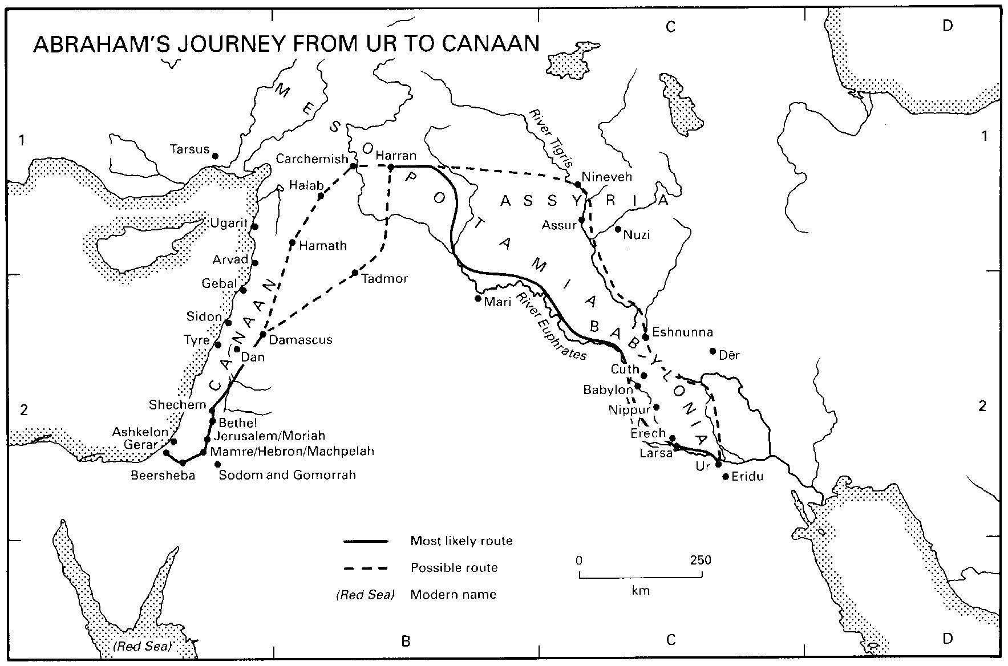

6) On the map above, circle the city where Abraham came from and draw a box around the kingdom of Canaan.
Name: Student #:
Date: HR:

Exit Ticket

- The Israelites created a Kingdom in the
- land of Mesopotamia
- Mediterranean Region
- Indus River Valley
- Egyptian kingdom

2) The Israelites also called Canaan the
- Land of Abraham
- Land of Great Potential
- Promise Land
- Land of Promise

3) The Israelites left Canaan because
- They realized the land wasn’t where they wanted to be
- They realized God had promised them a different land
- There was a horrible famine and they had to move
- They were invaded and forced to leave by outside armies

4) Who is believed to have led the Israelites to the land of Canan?
a) Siddhartha
b) Jesus
c) Abraham
d) Moses

