Name: Student #:
Date: HR:

Do Now

1) The Israelites created a Kingdom in the
a) land of Mesopotamia
b) Mediterranean Region
c) Indus River Valley
d) Egyptian kingdom

2) According to the Hebrew bible Abraham and his family migrated from_________________ to _______________(fill in the blanks)

3) According to the Hebrew Bible what did God promise Abraham?
(1 complete sentence) _____________________________________________________________________
_______________________________________________________________________________________________

4) The Israelites also called Canaan the
a) Land of Abraham
b) Land of Great Potential
c) Promise Land
d) Land of Promise

5) The Israelites left Canaan because
a) They realized the land wasn’t where they wanted to be
b) They realized God had promised them a different land
c) There was a horrible famine and they had to move
d) They were invaded and forced to leave by outside armies

Lesson Information

Title: Moses and the Exodus

Objective: I can create a comic book on Moses by annotating my text and citing text evidence.

Guiding Questions: Who was Moses?

Agenda: 1 – Text Analysis, 2 – Video Clip, 3 – Venn Diagram, 4 – Comic Strip

Ancient Events Timeline
Israelites move to Egypt to escape famine
1200 BC
Moses leads Israelites form Egypt
1290 BC
Shang Dynasty Begins (1st Chinese Civilization)
1750 BC
Hinduism ideas begin in India
1500 BC
Abraham travels to Canaan
1800BC
Boy King Tut becomes Pharaoh
1500 BC

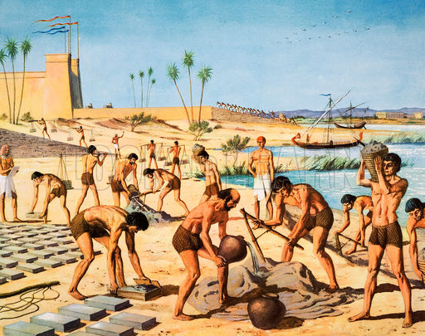
The Story of Moses
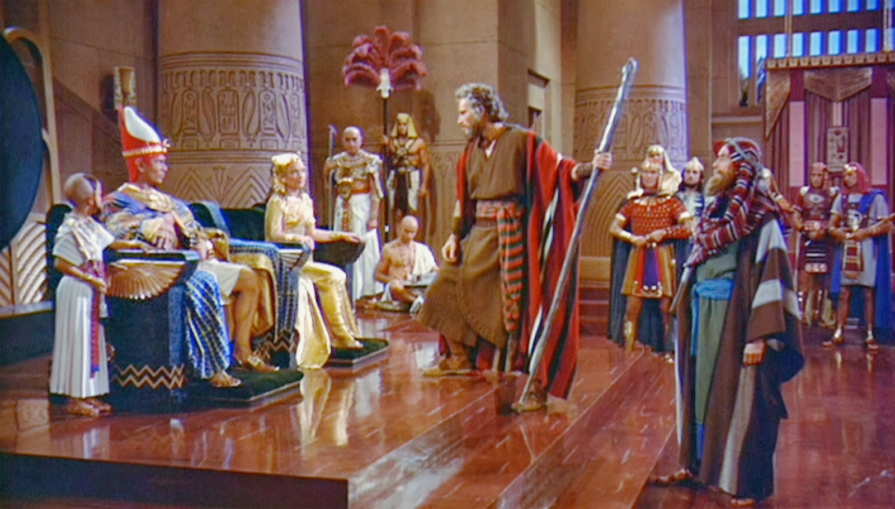
Moses was born to a woman Israelite living in Ancient Egypt. At the time the Egyptians were killing every male Israelite boy, by throwing them into the Nile River. Moses’ mother secretly took her newly born boy and placed him in a basket in the papyrus reeds of the Nile River. He was found by the Pharaohs wife who adopted him and raised him as Egyptian royalty. Moses grew up feeling uncertain about his loyalty and family. Was he an Israelite? Should he be slaving away with those people? Or was he an Egyptian pharaoh? One day when Moses was a young man he saw an Egyptian brutally whipping an Israelite man. Moses stepped in and killed the Egyptian. Confused, afraid and guilty Moses ran away from Egypt.

Moses was not finished with life in Egypt. According to the Hebrew Bible Moses saw a bush in flames. God called Moses from the burning Bush. He told Moses to return to Egypt and tell the Pharaoh to let the Israelites go.
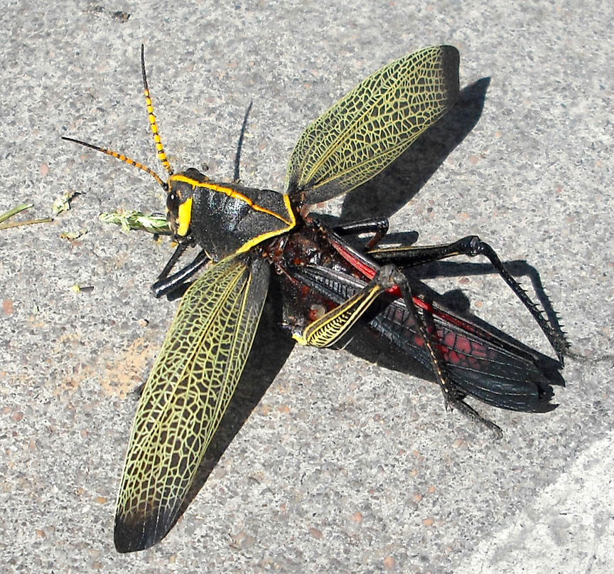
Moses went before the Pharaoh to demand the release of the Israelites. When the Pharaoh refused, God sent 10 plagues to Egypt. These plagues were events that caused problems for the Egyptians, such as locusts devouring the fields or outbreaks of diseases. The plague convinced the Pharaoh to free the Israelites. The Israelites left Egypt, determined to return to their Promise Land of Canaan. After the Israelites left, the Pharaoh changed his mind. He sent his army after the Israelites.
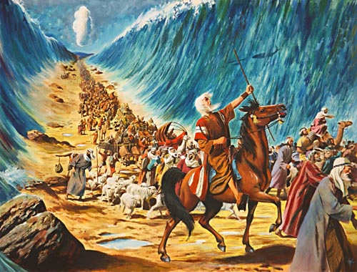
When the Israelites reached the Red Sea, there was no way to cross the waters. According to the Hebrew Bible, God parted he Red Sea to let his people cross to the other side. When the Pharaoh’s army tried to follow the waters flooded back and drowned them. The departure of the Israelites out of slavery in Egypt is known as the Exodus. Jews celebrate a holy festival called Passover to remember their freedom from slavery.

(You are expected to underline your evidence for each of the questions below.)

- How did God communicate with Moses?
Claim
Evidence

- When Pharaoh wouldn’t let the Israelites go what happened?
________________________________________________________________________________________________________________________________________________________________________________________________________________

- Moses is best described as
- savior
- son of god
- prophet
- founder of the Israelites

4) What was the Exodus?
________________________________________________________________________________________________________________________________________________________________________________________________________________

5) How did Moses grow up?
a) he grew up a shepherd among the Israelites
b) he grew up a noble among Egyptians
c) he grew up a soldier among the Hittites
d) he grew up a religious leader among the Hebrews

6) Circle the religion that believes in reincarnation on the timeline above the text.

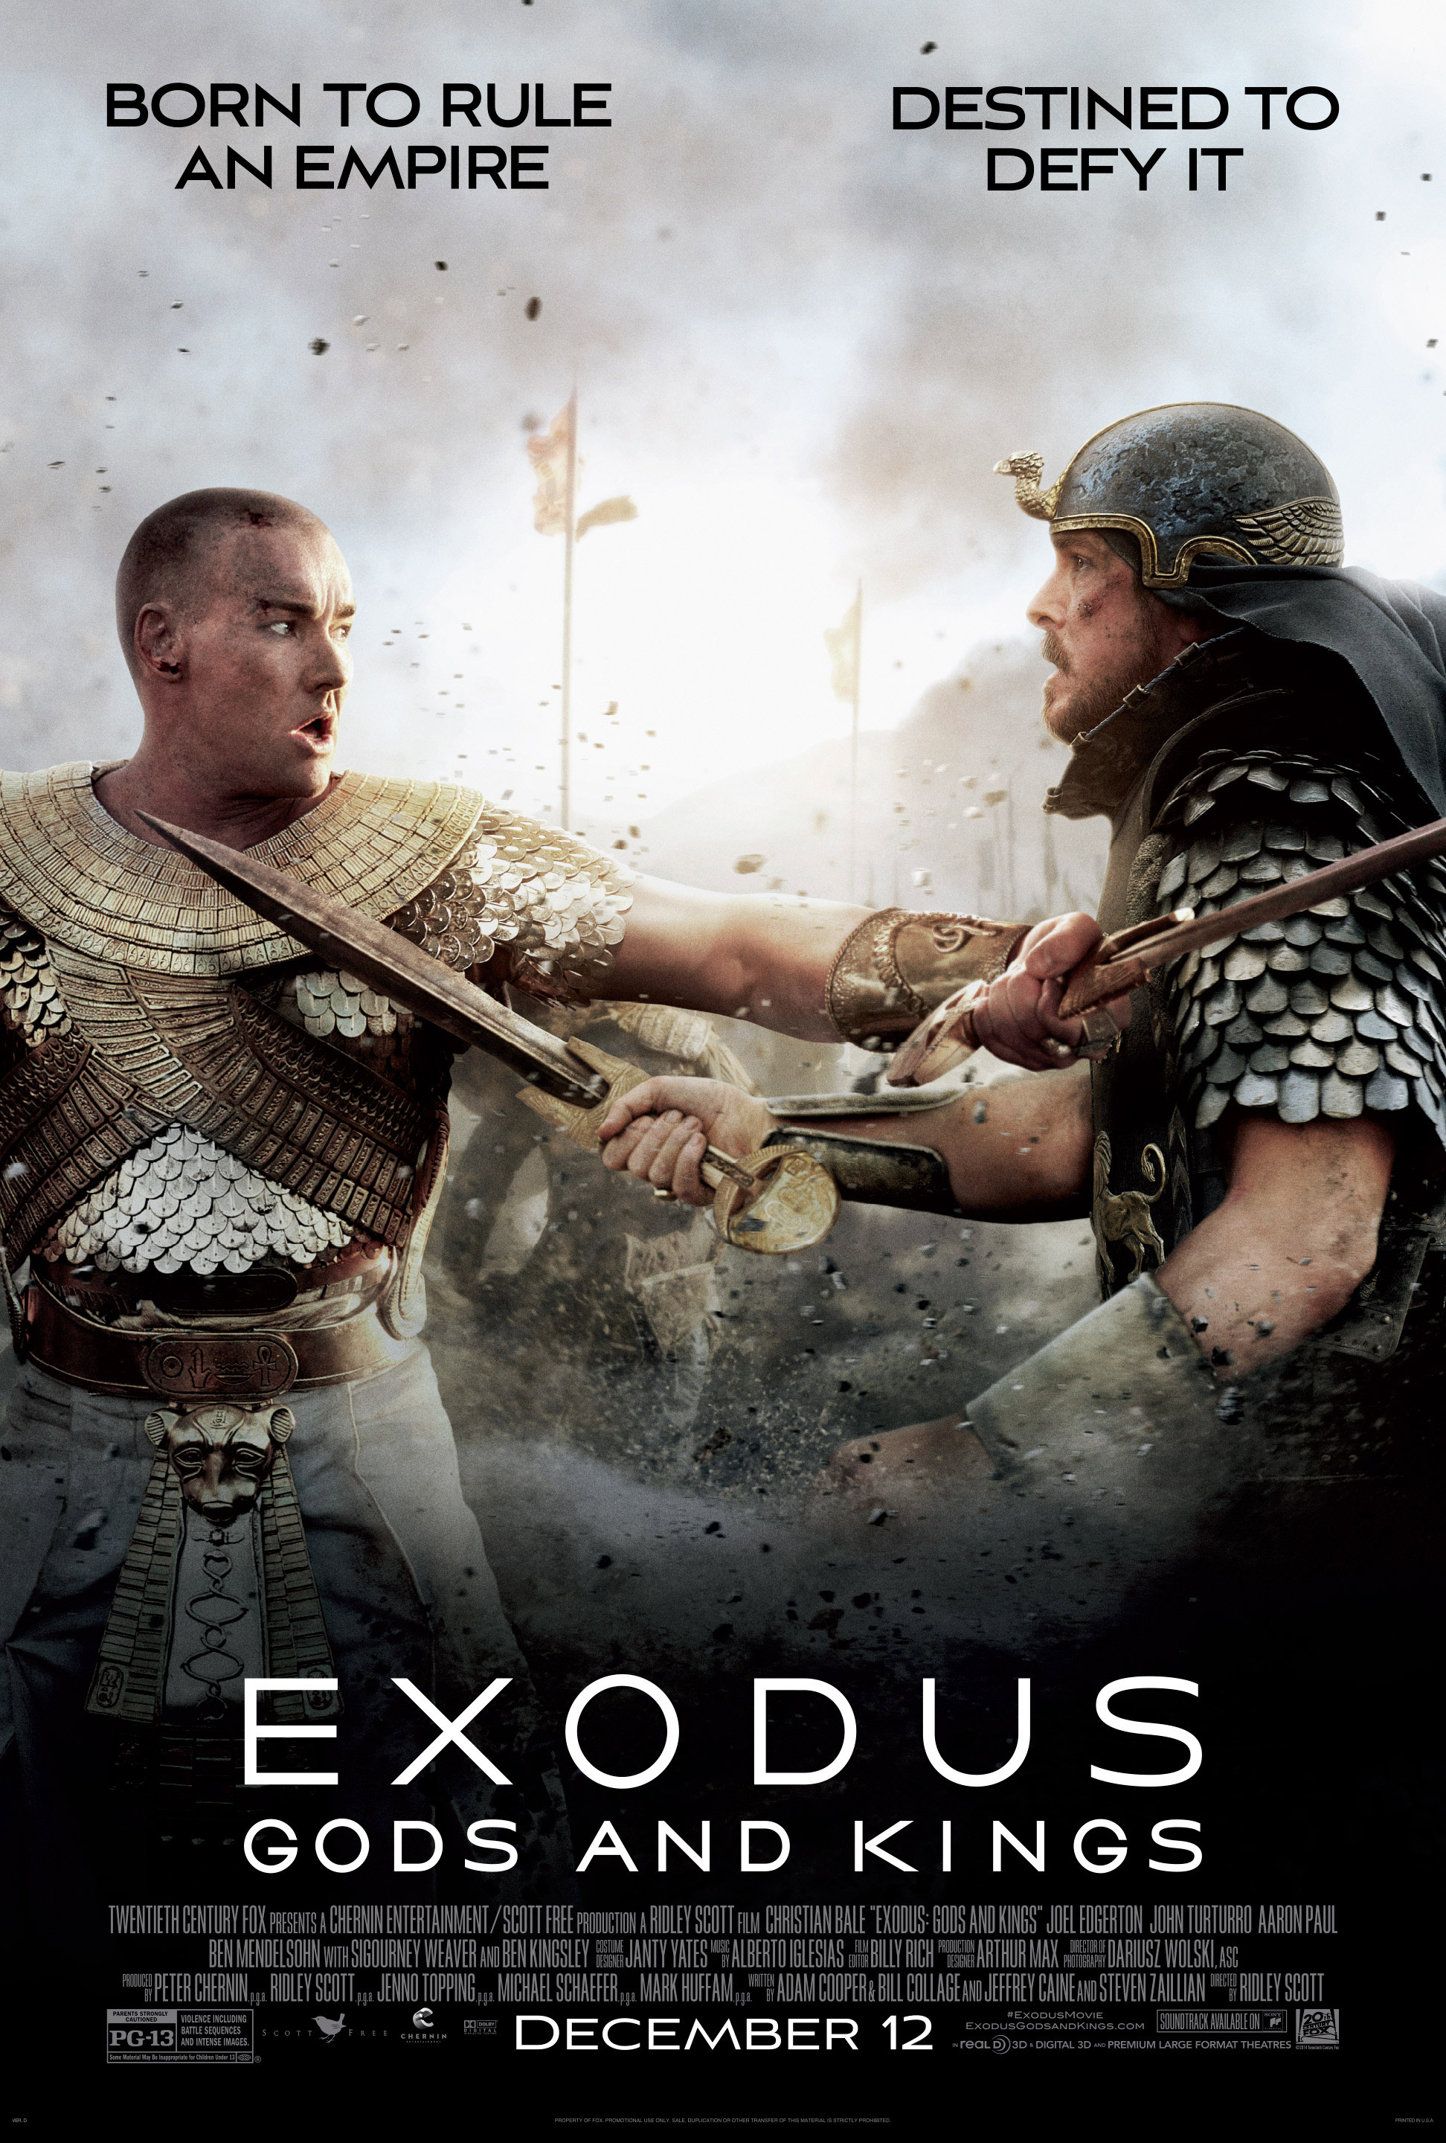
Video Clip – Exodus: Gods and Kings

Answer the questions below as we watch the clip.

https://www.youtube.com/watch?v=t-8YsulfxVI

1) Based on the visuals you see from the first few minutes, which ancient civilization does this movie appear to take place?
a) Canaan
b) Mesopotamia
c) Judah
d) Egypt

2) Who is the protagonist of this story?
a) Ramses
b) Moses
c) Abraham
d) Jacob

3) Does seem to believe he is an Israelite at first?
________________________________________________________________________________________________________________________________________________________________________________________________________________

4) In the clip we see the protagonist see a __________________________ bush.

5) Which of the plagues did you see in the movie trailer?
________________________________________________________________________________________________________________________________________________________________________________________________________________

6) Near the end of the trailer we see the Israelites cross the _____________ Sea.

According to the Hebrew bible, the Israelites can be traced back to a man named Abraham. Abraham and his family started the Israelites after God made a promise to Abraham. If Abraham left his home of Ur, in Mesopotamia and travelled to Canaan God promised that Abraham would have the land, forever. This land became known as the promise land because it was promised to Abraham and his descendants.

Moses is also considered a prophet of the Israelites. God communicated with Moses through a burning bush. According to the Hebrew Bible Moses delivered the Israelites from slavery in Egypt. The Israelites leaving Egypt is called the Exodus. The plan had been for the Israelites to leave Egypt and return to their promise land in Canaan.

Questions
- The Israelites leaving Egypt is called the ___________________________
- When the Israelites were leaving Egypt where were they going?
__________________________________________________________________________________________________________________________________
- Why is Canaan called the “Promise Land”? __________________________________
_________________________________________________________________

4) Compare and Contrast the 2 Israelite Prophets below..
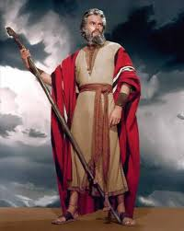
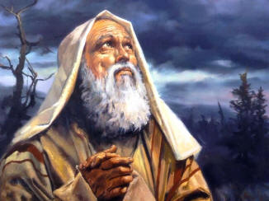

3 Events in Moses’ Life Comic Strip

You must illustrate three of the four events list below:
a) Moses grows up as an Egyptian noble
b) The Plagues hit Egypt
c) Moses see’s a burning bush
d) Moses receives the Ten Commandments
Name: Student #:
Date: HR:
e) The Israelites pass through a parted Red Sea

In addition to an illustration, you must include a written description that is (a) at least one complete sentence (must be original sentences).

________________________________  ________________________________  ________________________________  ________________________________  ________________________________  ________________________________  ________________________________  ________________________________ | ________________________________  ________________________________  ________________________________  ________________________________  ________________________________  ________________________________  ________________________________  ________________________________ | ________________________________  ________________________________  ________________________________  ________________________________  ________________________________  ________________________________  ________________________________  ________________________________

