Name: Student #:
Date: HR:
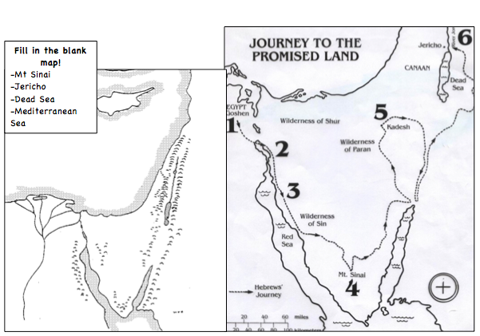
Do Now
1) Fill in the blank map above with the 4 terms listed.
2) Who led the Israelites from Mesopotamia to Canaan?  a) Moses  b) Ramses  c) Abraham  d) Jesus | 3) Why did the Israelite’s leave Canaan?  a) flood  b) famine  c) the descendants of Abraham demanded it  d) they were slaves and forced
Title: The Ten Commandments  Objective: I can choose one of the Ten Commandments and create a persuasive speech in order to persuade the Israelites to accept the new laws. | Guiding Question: How did the Ten Commandments influence life for the Israelites?  Agenda:

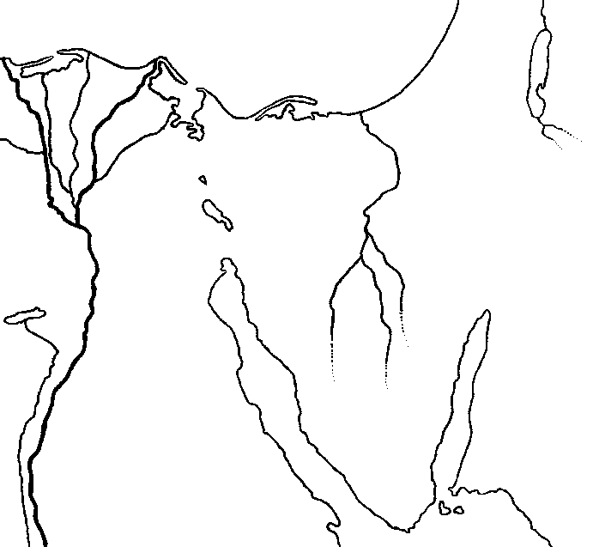
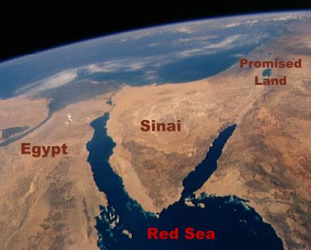

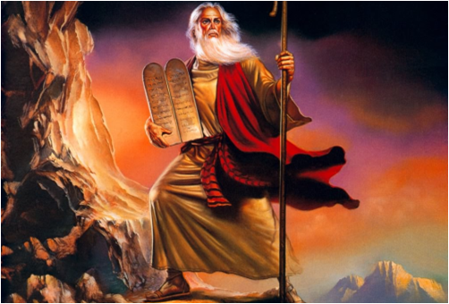
The Israelites cross the Red Sea and were determined to make their way back to Canaan.
Moses led the Israelites to Mount Sinai where according to the Hebrew Bible, the Israelites received a covenant or agreement with God. In the agreement, God promised to return the Israelites safely to Canaan if they promised to follow God’s teachings. Moses climbed to the top of Mount Sinai. On the top of Mount Sinai God gave Moses the Torah. The Torah had all of God’s teachings and it also made clear what God considered to be right and wrong. One important part of the Torah is the Ten Commandments.

- An Agreement with God is called a ____________________________________________.

- What was the covenant that the Israelites made with God?
_____________________________________________________________________________________________________

- What did Moses receive at the top of Mount Sinai?
_______________________________________________________________________________________________________

Video Break! https://www.youtube.com/watch?v=bUKVooRZhy8

Expectations: Sit up straight, pay attention, stay silent, and hold questions.

The Ten Commandments
Loyalty to God is the central idea of the Ten Commandments.

(1) You shall have no other gods before me
Meaning: Do not worship any gods except me
(2) You shall not make yourself an idol and bow down to worship them
Meaning: do not bow down and worship idols (objects)
(3) You shall not misuse the name of the lord
(4) Remember the Sabbath day, work 6 days but the seventh day you should keep it holy
(5) Honor your father and mother
(6) You shall not murder
(7) You shall not commit adultery
Meaning: be faithful in marriage (don’t cheat!)
(8) You shall not steal
(9) Do not give false testimony against your neighbor
Meaning: Do not lie about others
(10) Do not covet your neighbors belongings
Meaning: Do not want anything that belongs to someone else (greed)

- Which of the Ten Commandments do you think is important for the safety of people living in a community or society?
________________________________________________________________________________________________________________________________________________________________________________________________________________________________________________________________________________________________________________________

2)) Which of the Ten Commandments do you think is the least important for the safety of people living in a community or society?
________________________________________________________________________________________________________________________________________________________________________________________________________________________________________________________________________________________________________________________

3) Which of the Ten Commandments do you think would be the hardest to follow?
________________________________________________________________________________________________________________________________________________________________________________________________________________________________________________________________________________________________________________________

Comparing the Prophets
According to the Hebrew bible, the Israelites can be traced back to a man named Abraham. Abraham and his family started the Israelites after God made a promise to Abraham. If Abraham left his home of Ur, in Mesopotamia and travelled to Canaan God promised that Abraham would have the land, forever. This land became known as the promise land because it was promised to Abraham and his descendants.

Moses is also considered a prophet of the Israelites. God communicated with Moses through a burning bush. According to the Hebrew Bible Moses delivered the Israelites from slavery in Egypt. The Israelites leaving Egypt is called the Exodus. The plan had been for the Israelites to leave Egypt and return to their promise land in Canaan.

Questions
- The Israelites leaving Egypt is called the ___________________________________.

- When the Israelites were leaving Egypt where were they going?
________________________________________________________________________________________________________________________________________________________________________________________________________________

- Why is Canaan called the “Promise Land”? ____________________________________________
________________________________________________________________________________________________________

4) Compare and Contrast the 2 Israelite Prophets below..

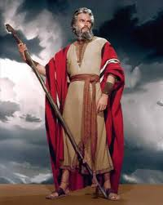
Abraham Moses
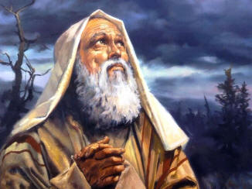

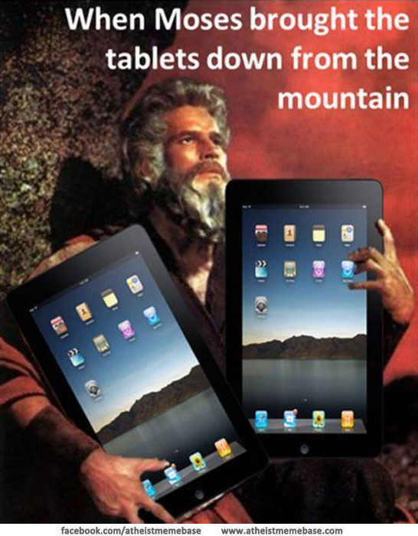
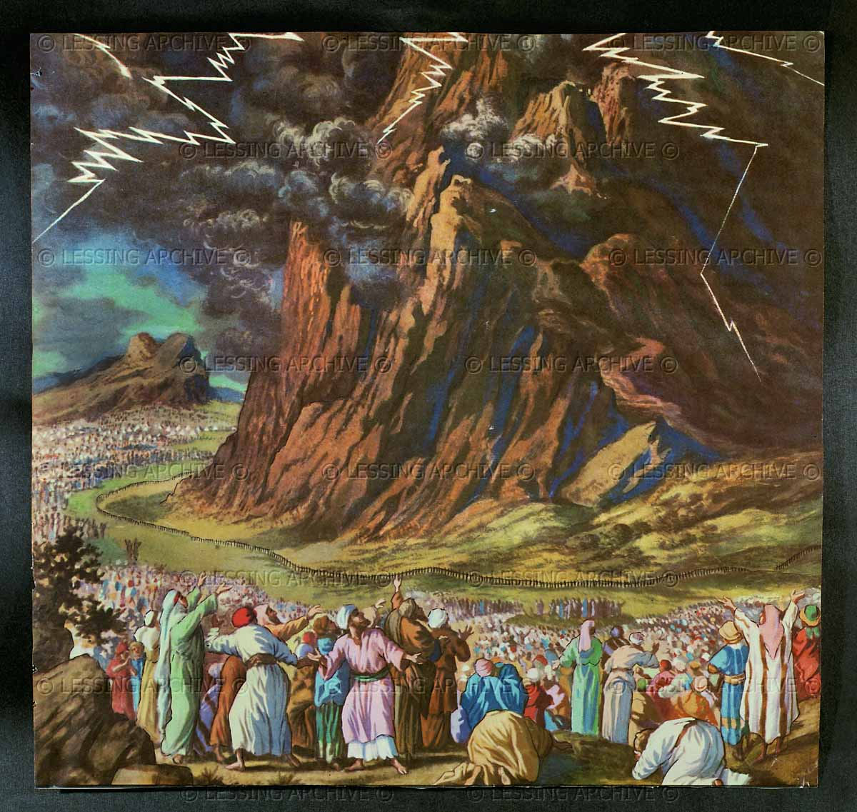
The Israelites waited for Moses at the bottom of Mount Sinai.

When he came down they read the Ten Commandments…some of them weren’t sure about these new laws that the Hebrew God had given them.

These were totally different then the laws of other lands.

The Torah and Ten Commandments weren’t like Egyptian law or Hammurabi’s Code! Could they agree to follow the Ten Commandments?

Persuasive Poster Assignment

Your task is to complete the following on the “stone” tablet on the next page. On your table, you must:
1) Write down one of the Ten Commandments
2) Illustrate someone following the commandment
3) Convince an ancient Israelite that he/she should follow this commandment in writing (complete sentences + be creative!)

Name: Student #:
Date: HR:

Exit Ticket

1) Monotheism is the belief in _______________ _________________ (2 terms).

2) Which of the following served as a law code for the ancient Israelites?
a. Hammurabi’s Code
b. the Constitution
c. the Torah
d. the Ten Commandments

3) How did the Israelites receive the Torah?
a. Moses received it while wandering the desert
b. Abraham brought it to Canaan from Ur
c. Moses received it on Mt. Sinai
d. Abraham found it in the Mediterranean Sea

4) Were kings and nobility expected to follow the same rules as the other Israelites? Explain your answer.
________________________________________________________________________________________________________________________________________________________________________________________________________________________________________________________________________________________________________________________

