Name: Student #:
Date: HR:

Do Now

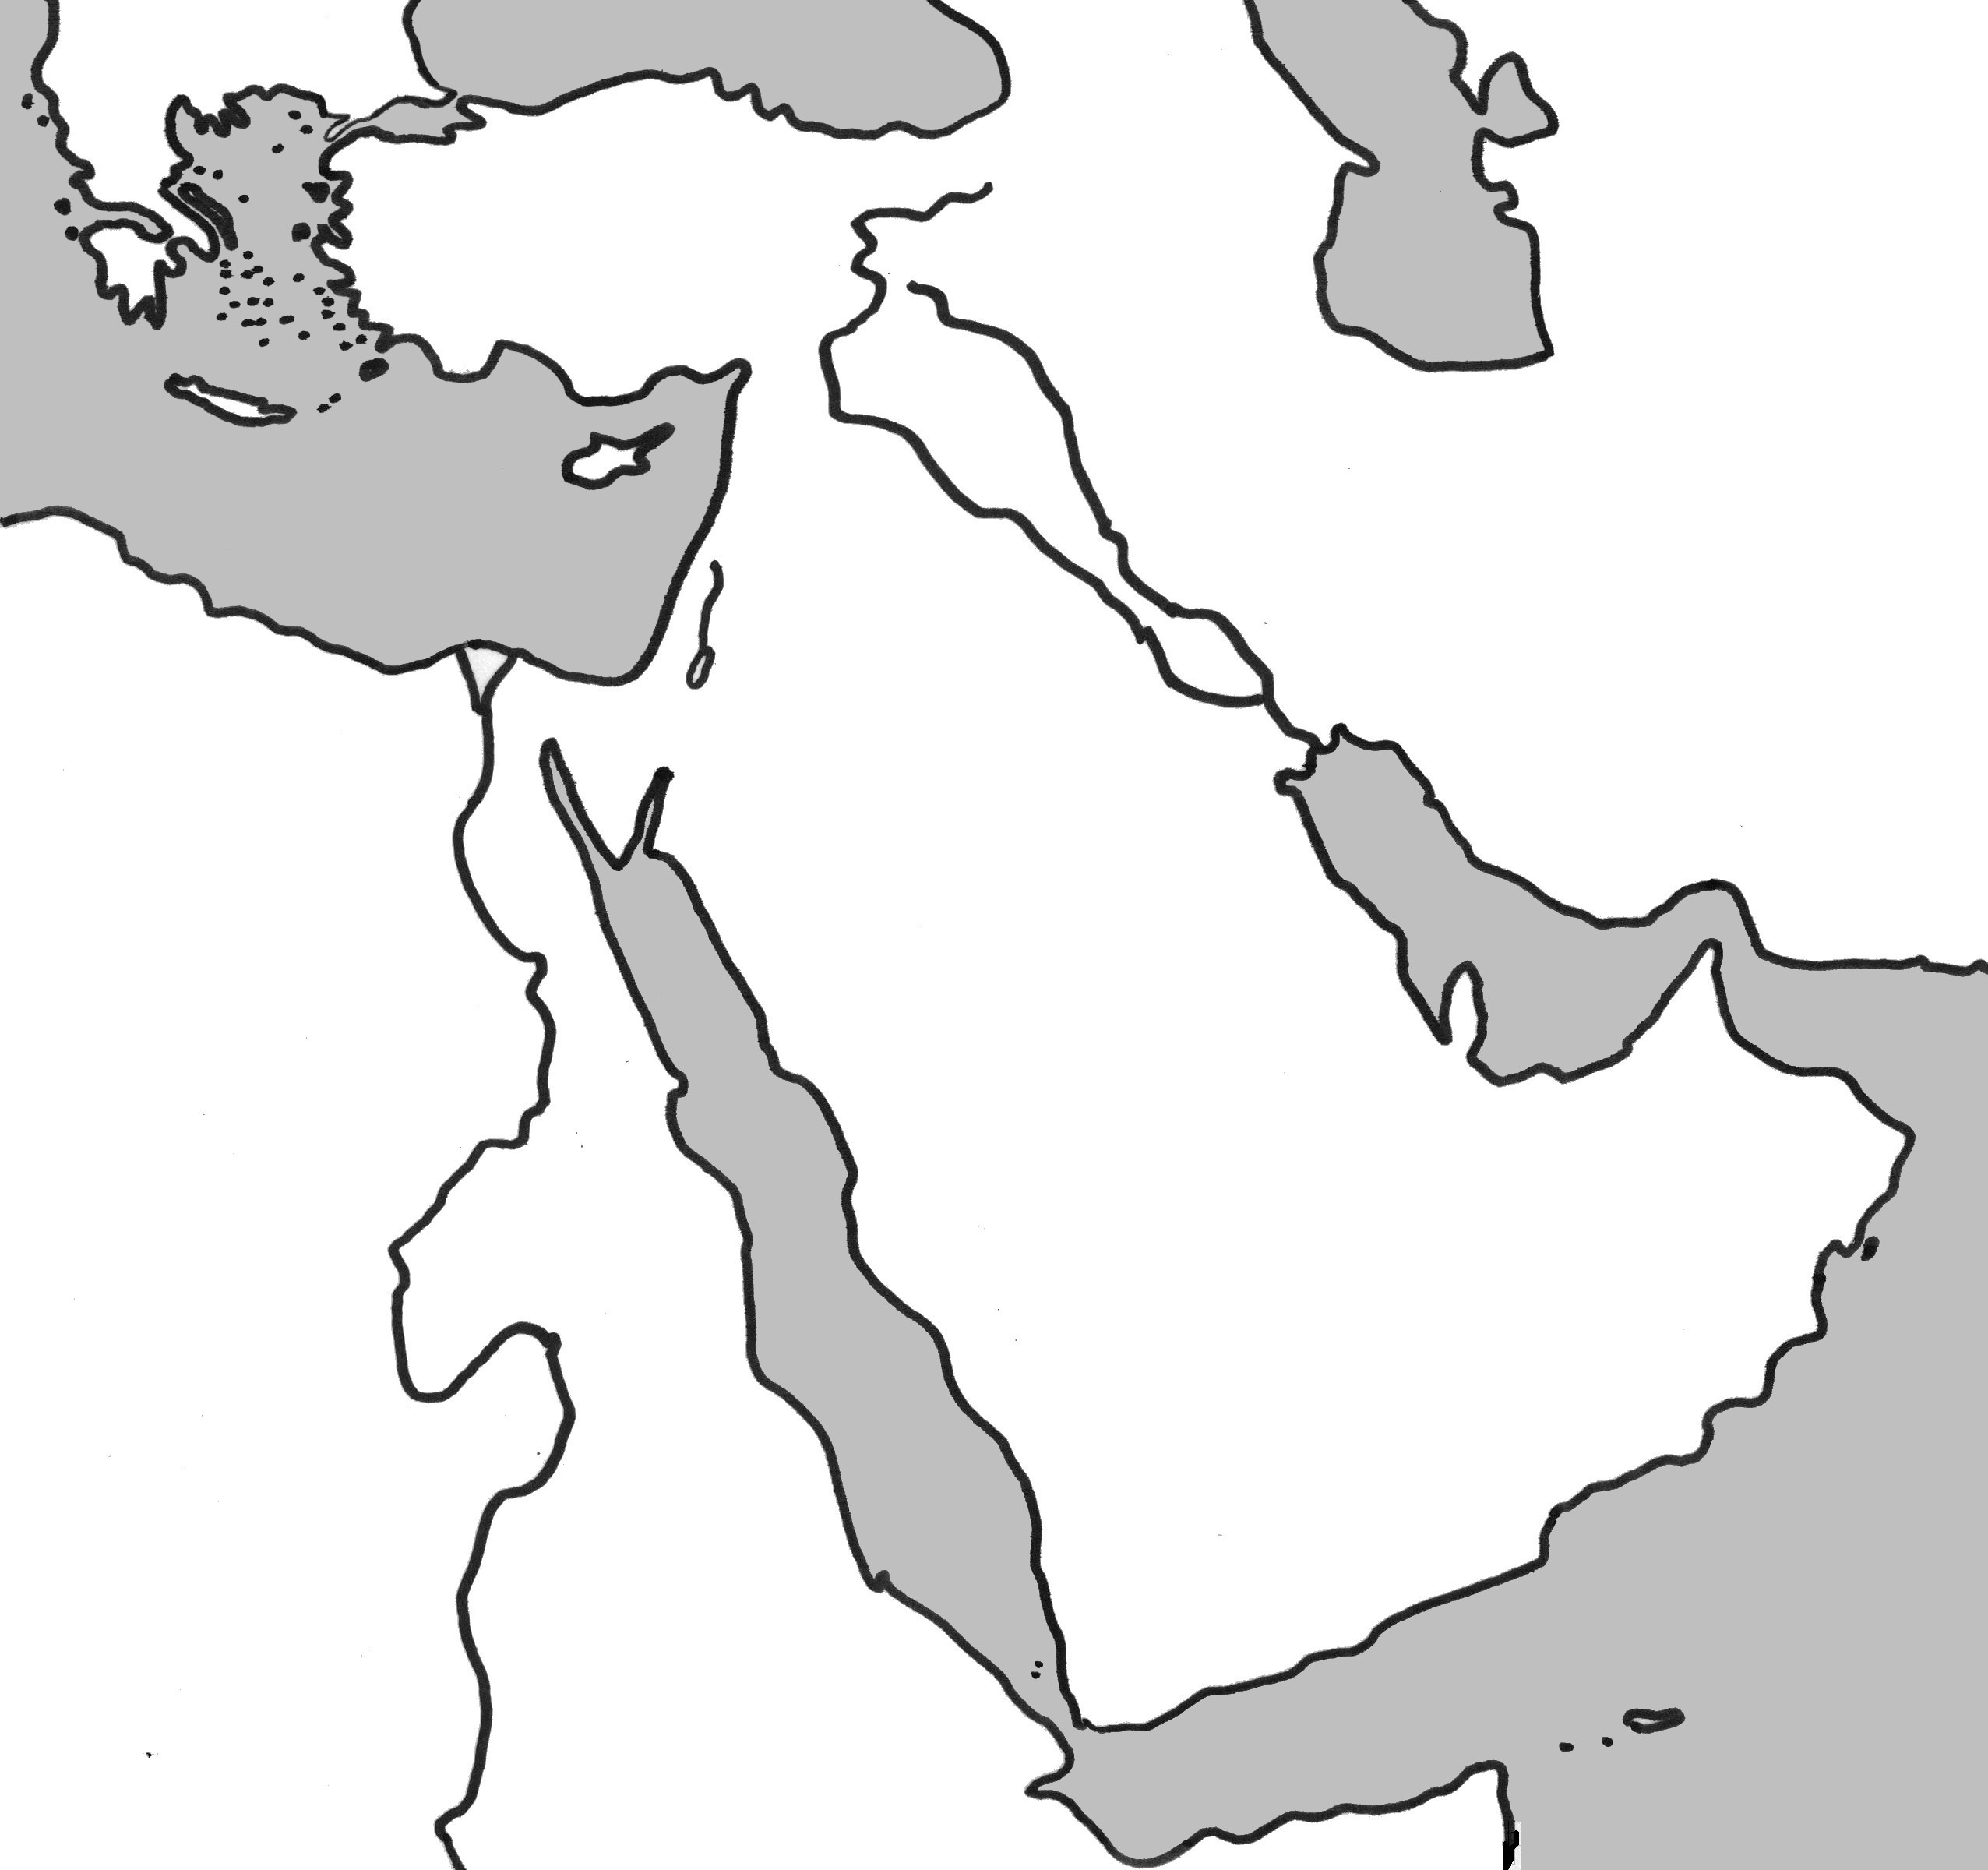
1) The Exodus tells the story of _______________________; the prophet who led the ____________________________________ out of Egypt.
a. Siddhartha, Harrapans
b. Jesus, Christians
c. Abraham, Hebrews
d. Moses, Israelites

2) In your own words, describe what “monotheism” means.
____________________________________________________
____________________________________________________
____________________________________________________
____________________________________________________
____________________________________________________
____________________________________________________
____________________________________________________

3) Illustrate (using three types of shading) the following kingdoms on the map to the right: Canaan, Egypt, & Mesopotamia

Lesson Information

Title: Ten Commandments vs Hammurabi’s Code

Objective: I can answer a challenging document based writing prompt by using a five point paragraph.

Guiding Question: How are the Ten Commandments and Hammurabi’s Code alike and different?

Agenda:
1) Document Analysis (A, B, C)
2) Five Point Paragraph

Document A: The Ten Commandments

The Hebrews in ancient Mesopotamia were one of the first groups to practice monotheism, the worship of only one God. The Hebrews recorded their history and laws in the Hebrew Bible, which tells the story of God meeting Moses on a mountain. God gave Moses a set of laws called the Ten Commandments. These laws gave rules for how the Hebrews were to treat both God and other men.

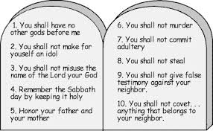
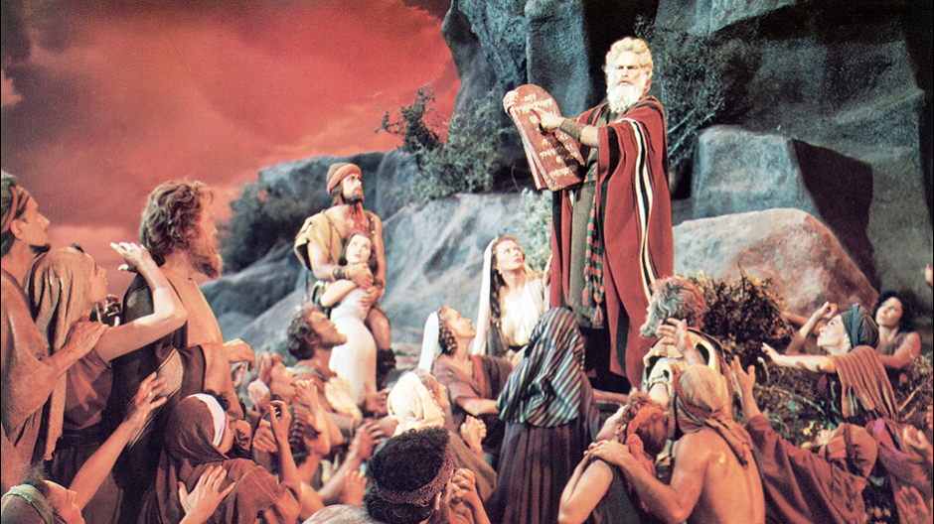

1) “The worship of only one God” is a definition for which of the following terms?
a. monotheism
b. polytheism
c. mythology
d. Judaism

2) Who was believed to have given Moses the Ten Commandments?
______________________________________________________________________________________________________________________________________________________________________________________________________________________________________________________________________________

3) How did the Ten Commandments address stealing?

Claim
Evidence

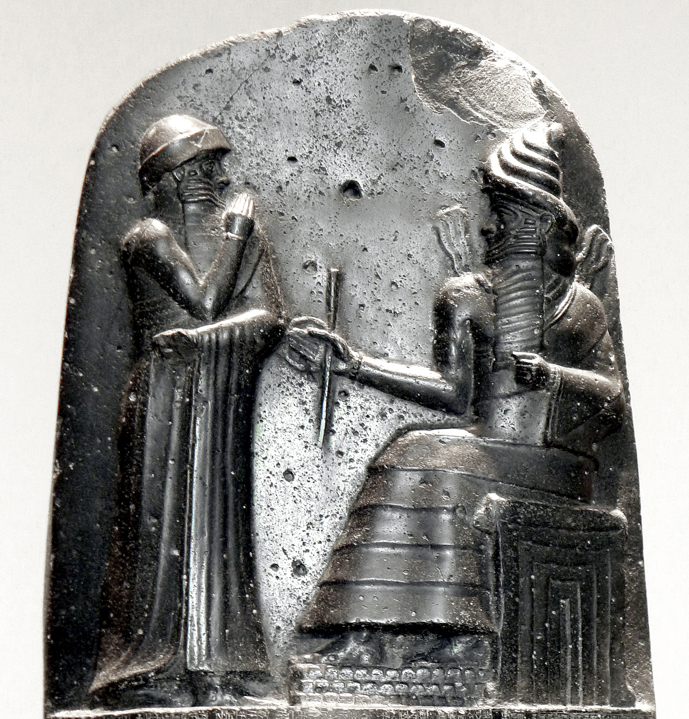
Document B: Top of Hammurabi’s Code Stele

Moses wasn’t the only man who had claimed to receive laws from God. Hammurabi, a ruler of ancient Babylon in Mesopotamia, came up with a set of laws for his people to live by as well. The collection of these laws were called the Code of Hammurabi. The laws were written on a stele, or stone slab. The Babylonians believed Hammurabi received these laws from a god.

1) Which Mesopotamian empire was ruled by Hammurabi?
a. Akkadian
b. Assyrian
c. Babylonian
d. Persian

2) The Ten Commandments were written on stone. Hammurabi’s Code was written on a _____________________, or stone slab.

3) According to the Babylonians, how did Hammurabi get these laws?

Claim
Evidence

Document C: Excerpts from Hammurabi’s Code

If a son strike his father, his hands shall be hewn off.

If a man knock out the teeth of his equal, his teeth shall be knocked out.

If anyone is committing a robbery and is caught, then he shall be put to death.

"If a man has destroyed the eye of a man of the gentleman class, they shall destroy his eye .... If he has destroyed the eye of a commoner ... he shall pay one mina of silver. If he has destroyed the eye of a gentleman's slave ... he shall pay half the slave's price."

1) True or False: Hammurabi’s Code was just. (Circle your answer)

2) Put a star next to the quote that helped you answer #1.

3) How did Hammurabi’s Code address stealing?

Claim
Evidence

Name: Student #:
Date: HR:

Based on your knowledge of world history and the information in the documents above, would you argue the Ten Commandments and Hammurabi’s Coder were more alike or different?

Claim: (answer the question in one sentence) 1 point
Evidence: (cite 1-2 sentences of evidence that prove your claim) 1 points
Explanation of Evidence: (write the evidence in your own words) 2 point
Conclusion: (summarize your claim, evidence, and explanation). 1 point

Total: __________/5 Points 20% 40% 60% 80% 100%

