Name: Student #:
Date: HR:

Do Now
3) What is one way Hammurabi’s Code and the Ten Commandments were similar?
___________________________________________________________________________________________________________________________________________________________________________________________________________________________________________________________________

4) The Israelites divided themselves into ______ tribes.

1) What landform did the Israelites have to cross in order to leave Egypt?
a) Mediterranean Sea
b) Arabian Desert
c) Plateau of Tibet
d) Red Sea

2) According to the Hebrew Bible Moses received teachings from God called
- the Bible
- the Torah
- The Talmud
- The Quran

Lesson Information
Title: The Israelites Return to Canaan

Objective: I can analyze texts and image to answer questions relating to the Israelites’ experiences moving back to Canaan.

Objective: How did the Israelites re-claim Canaan?

Agenda:
1) Prediction
2) Video Clip
3) Paired Work
4) Independent Work
5) Exit Ticket

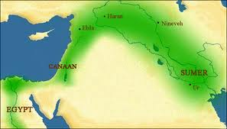
The Israelites were headed back to the Promise Land, Canaan. They believed it was their land, promised to the prophet Abraham and his descendants.

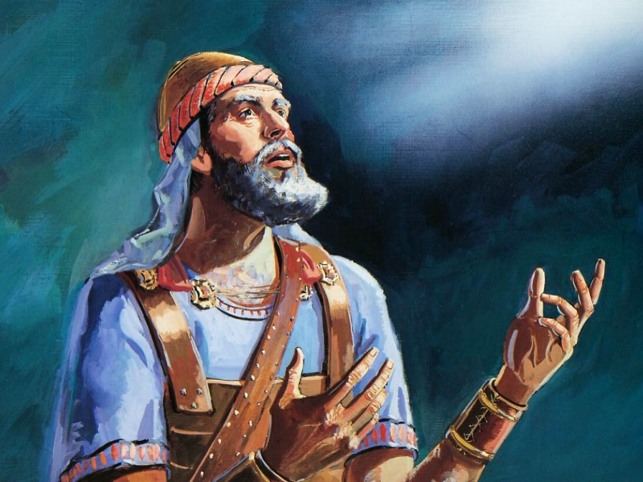
When the Israelites arrived in Canaan they found other people living there. These people included the Phoenicians and the Philistines. Unlike the Israelites these people of Canaan worshiped many gods and goddesses. They also had different ways of life.

RIP MOSES
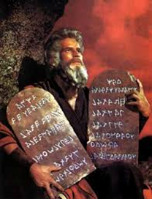
According to the Hebrew Bible, Moses died before the Israelites reached the land God promised them. A new leader Joshua guided the Israelites into Canaan
Before becoming a leader, Joshua was sent by Moses to spy on the land of Canaan to see what awaited the Israelites. Joshua saw that the land was inhabited by new people.

Make a Prediction!
Write one sentence describing what you THINK will happen when the Israelites get back to Canaan

Joshua Clip:

https://www.youtube.com/watch?v=JxJUJ13AqH0
_______________________________________________________________________________________________________________________________________________________________________________________________________________________________________________________________________________________________________________________________________________________________________________________________

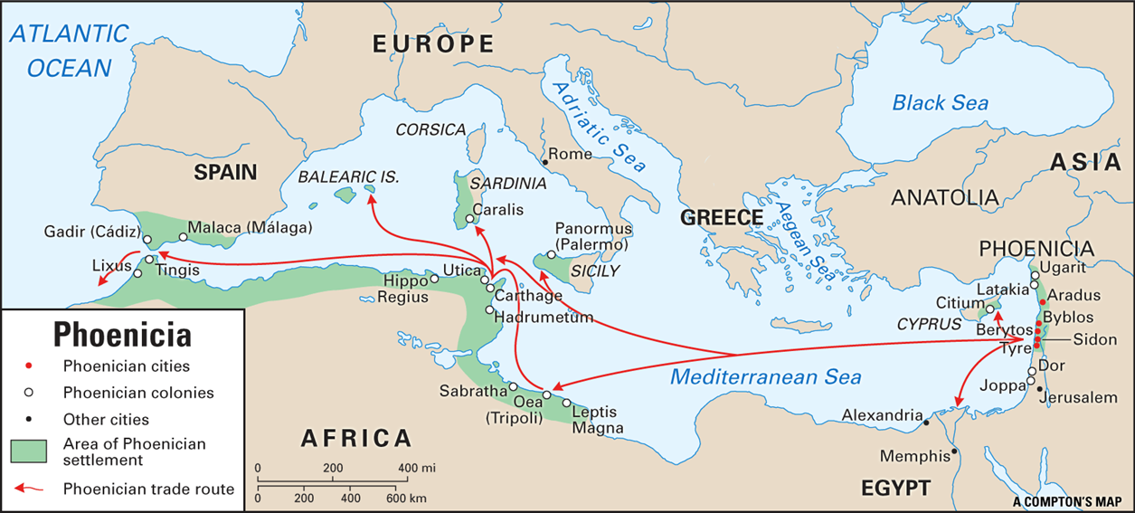
Who was living in Canaan at the time?

Phoenicians
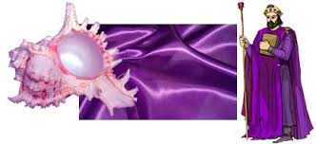
Many different groups lived in Canaan. One Canaanite group was the Phoenicians. The Phoenicians lived in cities along the Mediterranean Sea in northern Canaan. The Phoenicians were skilled sailors and talented traders. They used the sun and the stars to plot long sea voyages. Phoenicians ships traded all the way across the Mediterranean Sea to Greece even West Africa and Spain. The Phoenicians controlled the Mediterranean Sea. At various ports they traded jewelry, tin, metals glass but the Phoenicians also traded something else, something special. The Phoenicians learned how to create purple dye from shellfish along the Phoenician coast.
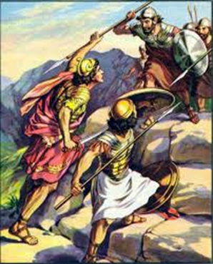
The Phoenicians were such strong traders that they had settlements all along the coasts of the Mediterranean Sea. As a result of these settlements, Phoenician ideas and goods spread to other peoples. One of the important contributions was an alphabet. The Phoenician alphabet was spread all across the Mediterranean area even to Greece and Rome.

Philistines
Another group in Canaan were the Philistines. These Philistines set up five walled towns in southern Canaan along the Mediterranean Coast. They were skilled in making tools and weapons which helped them create the strongest army in Canaan.
Phoenician Alphabet

Questions: (underline in the text where you find your answer)

- What were the Phoenicians skilled at?
_______________________________________________________________________________________________________________________________________________________________________________________________________________

- What did the Phoenicians trade that was special?
________________________________________________________________________________________________________________________________________________________________________________________________________________

- “Phoenician ideas and goods spread to other people” this is an example of
a) cultural exchange b) cultural diffusion c) cultural difference d) exile

- Who had the strongest army in Canaan?
a) the Israelites b) the Philistines c) the Egyptians d) the Phoenicians

5) How did the Phoenicians contribute to Greek and Roman society?

Claim
Evidence
Explanation

The Israelites Take Back Canaan
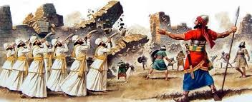
Because other groups lived in the region, the Israelites faced a challenge establishing Canaan as their new homeland. They believed, however that it was God’s will that they claim the land. Joshua led them in a series of battles to conquer Canaan.

The Hebrew Bible tells about the battle at the city of Jericho. There Joshua told the Israelites to march around the city walls. For six days they marched while priests blew their trumpets. On the seventh day when the people shouted and the trumpets blasted the walls collapsed. Joshua led the Israelites in other battles. Any land seized was divided among the 12 tribes.

1) Who led a series of battle to conquer Canaan?
a. Moses
b. Joshua
c. Solomon
d. Abraham

2) What happened to the land that the Israelites seized?
________________________________________________________________________________________________________________________________________________________________________________________________________________________________________________________________________________________________________________________

3) How did the Israelites justify taking this land from other people?

Claim
Evidence

Life in Canaan
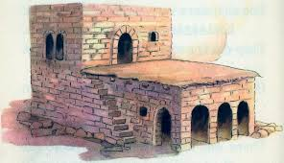
After many battles the Israelite tribes won control of the hilly central region of Canaan and they settled there. Most Israelites learned to farm and herd animals. The land was rocky and dry with little water. So during the rainy season farmers collected rainwater. They stored it in small caves or under the ground. They used the water to irrigate crops. Imagine a rocky countryside dotted by square white houses. Most Israelites lived in houses with two levels. The walls of the houses were made of mud-brick or stone plastered with mud and white washed. Floors were made of clay. Wooden beams supported a flat roof covered with sticks and clay. During the day people cooked and did household chores in the lower bottom of the house. At night donkeys and goats bedded down there. The family slept on the upper level.
1) Look at the pictures and use the text to describe what a regular house for an Israelite in Canaan looked like. ________________________________________________________________________________________________________________________________________________________________________________________________________________________________________________________________________________________________________________________

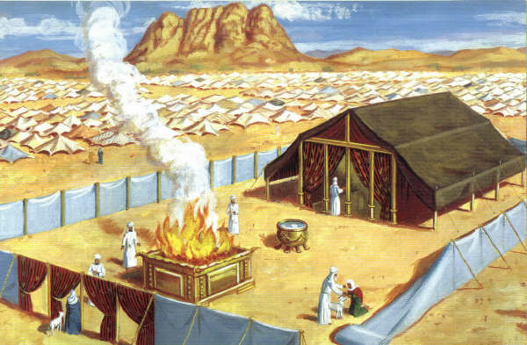
The Tabernacle
According to the Hebrew Bible the Israelite tribes worshipped God in a large tent like structure called the tabernacle. The Israelites believed the tabernacle housed God’s presence. This structure was taken down and put away as the Israelites moved from place to place. In Canaan they erected the tabernacle in the city of Shiloh.
The Hebrew bible says that the tabernacle housed a sacred object called the Ark of the Covenant. The ark, a gold covered wooden chest, held tablets or stone slabs. The Israelites believed that the Ten Commandments were written on these tablets. The Israelites believed the ark was a sign of God’s presence and that having it with them in battle would ensure victory.

2) Based on the text above and your knowledge of world history, why did the Israelites worship in the tabernacle?
a. they believed that they could not be defeated
b. they believed it housed the presence of the Hebrew God
c. they thought it was promised to them

Name: Student #:
Date: HR:

Exit Ticket

- What leader guided the Israelites to Canaan?
- Abraham
- Moses
- Solomon
- Joshua

- This group of people were skilled traders and sailors. They controlled the Mediterranean Sea.
- Israelites
- Canaanites
- Phoenicians
- Philistines

- The Phoenicians used shellfish to create
- the alphabet we use today
- a purple dye that they traded
- walled cities such as Jericho
- clay tablets to write cuneiform on

- The Israelites worshiped in a
- church
- synagogue
- temple
- tabernacle

