Name: Student #:
Date: HR:

Do Now
- What leader guided the Israelites to Canaan?  - Abraham  - Moses  - Solomon  - Joshua | - This group of people were skilled traders and sailors. They controlled the Mediterranean Sea.  - Israelites  - Canaanites  - Phoenicians  - Philistines
- The Phoenicians used shellfish to create  - the alphabet we use today  - a purple dye that they traded  - walled cities such as Jericho  - clay tablets to write cuneiform on | - The Israelites worshiped in a  - church  - synagogue  - temple  - tabernacle
5) Would the king of the Israelites get special exceptions for following the Ten Commandments?
________________________________________________________________________________________________________________________________________________________________________________________________________________________________________________________________________________________________________________________________________________________________________________________________________________________________

Title: The Three Kings of Israel

Objective: I can create a foldable to highlight the accomplishments of Saul, David and Solomon.

Guiding Question: How did each king change Israel?

Agenda:
1) Text Analysis
2) Foldable Creation
3)Exit Ticket

Early Kings
By 1100 BC the Israelites had settled much of the land of Canaan. They developed a culture and life. Yet a powerful enemy still remained. The Philistines. When the Philistines moved inland from the Mediterranean Sea they came into conflict with the Israelites. Many Israelites called for a King to unite the Twelve Tribes and lead them in battle against the Philistines.

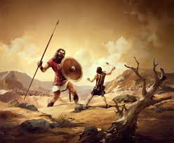
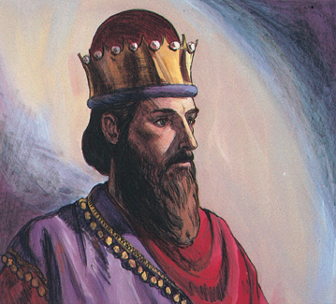
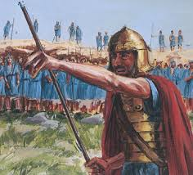
Saul: The First King King David King Solomon

As we read we are looking to answer the questions
- Who were the first three kings of Israel?
- What were the accomplishments of these kings?
- What happened to Israel after these Kings?

We will create a foldable by the end of class

You’re foldable will have pictures on the front showing the King or his accomplishment

You’re foldable will have his accomplishments inside.

You’re foldable will have 3 pieces of text evidence using:
- According to the text, “_________________________________________.”
or
- The text states, “_________________________________________.”

Saul: The First King
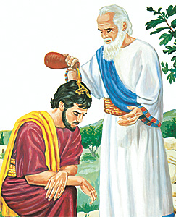
According to the Hebrew Bible, the Israelite asked the judge Samuel to choose a king. Samuel, though, warned that a king would tax them and enslave them. The Israelites, however, still demanded a king so Samuel chose a young man named Saul. Samuel anointed Saul as king, pouring holy oil on him to show that God blessed him.
Under Saul’s leadership the Israelites won many battles against the Philistines. With each victory, Saul gained greater fame. Later, however, Saul lost the support of the people.
According to the Hebrew Bible, Saul disobeyed some of God’s commands. God then instructed Samuel to choose and anoint another King. Samuel chose a young shepherd boy named David.

1) Who chose the first king of Israel?
a. the shepherd boy David
b. the warrior Saul
c. the judge Samuel
d. the prophet Joshua

2) Why did Samuel choose a King to replace Saul?

Claim
Evidence
Explanation

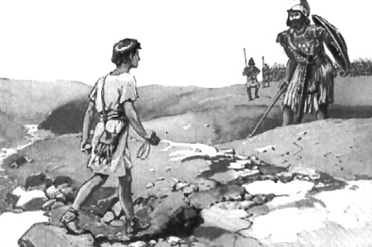
King David
Even before he was King, David was very well known in Israel. The Hebrew Bible tells the story of David defeating Goliath, a giant Philistine warrior. Goliath was a giant warrior who boasted and bragged, his ego was large enough to fit his giant head. Goliath dared any Israelite to fight him one on one. David, who was just a young shepherd boy at the time, stepped forward and volunteered to fight the deadly giant. With a heavy spear in his hand Goliath rushed forward towards the young shepherd boy. David held his slingshot and five smooth stones. David hurled one stone straight at the giant’s forehead. Goliath dropped dead.
When David was King of Israel he united the twelve tribes. David and his army defeated the Philistines. He established the capital city of Israel in the city of Jerusalem.
3) What did David do before he was king?
a. he defeated a Philistine in combat
b. he defeated a Phoenician in trading
c. he defeated an Egyptian in battle
d. he defeated an Israelite in archery

The Star of David

4) Where did David create the capital city?

Claim
Evidence

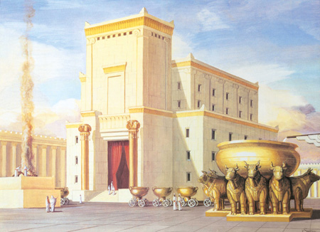
King Solomon
King David’s son Solomon became the next Israelite King. Through trade deals and peace treaties with other people, Solomon brought a long period of peace to the region. Solomon constructed many cities and, according to the Hebrew Bible, built the first temple in Jerusalem.
Built of cedar wood and expensive stone, Solomon’s temple-also called the First Temple, held the Ark of the Covenant.
Despite King Solomon’s accomplishments many Israelites turned against him. They did not like working on his building projects or paying the high taxes he demanded. After Solomon’s death the Israelites entered a troubled period in their history. Deep disagreements split their kingdom. In addition, powerful neighbors threatened their survival.

1) How did Solomon bring peace to Israel?
a. he subdued the people around him through conquest
b. he traded enough goods to secure stability all around the Mediterranean Sea
c. he made peace treaties and trade deals
d. he established permanent peace in the Middle East region

2) How did Solomon improve Jerusalem?

Claim
Evidence

Independent Practice
Three Kings of Israel Foldable

You are going to create a foldable to highlight the accomplishments of the three kings we learned about today. Each king will have his own section on the foldable (three sections total). In each section you must:
a. Write a claim answering the following question: Why is this king significant?
b. Cite textual evidence to support your claim (According to the text,”__________.”)
c. Illustrate something that demonstrates this leader’s significance

Saul | David | Solomon
Claim  Evidence  Illustration | Claim  Evidence  Illustration | Claim  Evidence  Illustration

* You must complete ALL of your claim and evidence sentences before starting your illustration.

Name: Student #:
Date: HR:

Exit Ticket

- Who did the Israelites have to defeat in order to live in Canaan?
- Phoenicians
- Philistines
- Israelites
- Egyptians

- Why did the Israelites demand a king?
- they wanted to unite with the Philistines to take over Canaan
- they wanted to unite the 12 tribes to defeat the Philistines
- they wanted to be told how to live and what to do
- they wanted to pay high taxes and enslave them

- Who chose the first king of Israel?
- Saul
- Solomon
- David
- Goliath

- The city of Jerusalem was made the capital by
- King Samuel
- King Solomon
- King Saul
- King David

- The first temple in Jerusalem was built by
- King Samuel
- King Solomon
- King Saul
- King David

- The Israelites turned against Solomon because
- Solomon was defeated by Goliath
- Solomon disobeyed God’s rules
- Solomon brought a long period of war
- Solomon’s building projects weren’t popular

