Name: Student #:
Date: HR:

Do Now
1) Who did the Israelites have to defeat in order to live in Canaan?  - Phoenicians  - Philistines  - Israelites  - Egyptians  2) Why did the Israelites demand a king?  a) they wanted to unite with the Philistines to take over Canaan  b) they wanted to unite the 12 tribes to defeat the Philistines  c) they wanted to be told how to live and what to do  d) they wanted to pay high taxes and enslave them  3) Who chose the first king of Israel?  - Saul  - Solomon  - David  - Goliath | 4) Place the kings in the correct order  David Solomon Saul  First-----______________________  Second-_______________________  Third---_______________________  5) The city of Jerusalem was made the capital by  - King Samuel  - King Solomon  - King Saul  - King David  6) The first temple in Jerusalem was built by  - King Samuel  - King Solomon  - King Saul  - King David

Lesson Information

Title: Assyrian Rule in Israel

Objective: I can analyze images and text to answer questions relating to the Assyrian Empire’s conquest of Israel.

Guiding Question: How did the Assyrians impact life for the Israelites?

Agenda:
1) Map Analysis 4) Independent Work
2) Text Analysis 5) Three Kings Foldable Work Time
3) Paired Review
After Solomon’s death the Israelites broke into separate Kingdoms. There was Israel and Judah. The capital of Israel was Samaria. The capital of Judah was Jerusalem. Although the two regions split politically (different political leaders such as kings) the people of Israel and Judah were both practicing the Israelite religion.

During this time large empires formed around Israel and Judah. Both the Assyrians and a people called the Chaldeans from Mesopotamia built powerful empires. Their rulers wanted to control the trade routes that ran through the two Israelite kingdoms. Small and weak, both of these kingdoms felt threated by their powerful neighbors.
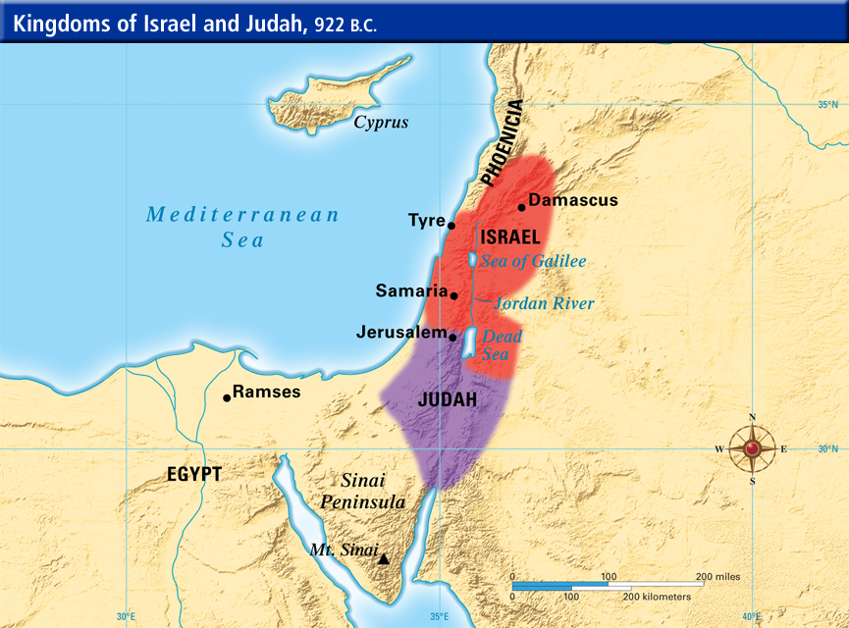

Use the map above to answer the questions below:
1) List the cities that lay within Israel’s borders:
-
-
-
2) Circle the Nile River on the map.
3) If you were in Judah, which direction would you have to travel to get to the Mediterranean Sea? _____________________________________________________________________________
Document 1: Under Assyrian Control
The Assyrians were spreading fear throughout the region. They forced conquered peoples to pay tribute. If they did not receive tribute, the Assyrians destroyed towns, burned estates and carried away all valuable goods. Then they forced the conquered people to move to different areas to start new settlements.
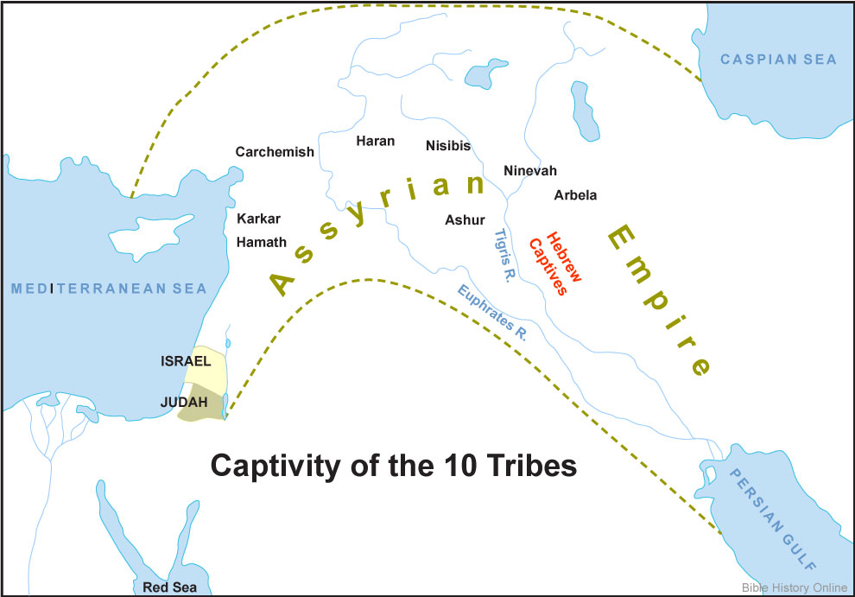
When the kingdom of Israel refused to pay tribute, the Assyrians invaded Israel in 722 B.C. The Assyrians captured major cities, including the capital at Samaria. They wanted absolute control. The Assyrians forced some of the Israelites to resettle in the Assyrian Empire, then brought people from other parts of the Empire to live in Israel. A new mixed culture developed called the Samaritans.

1) On the map above, draw a box around the land of Canaan and circle where the Hebrew’s were brought to after the Assyrians took control.

2) Why did the Assyrians force the Israelites to move?
Claim
Evidence
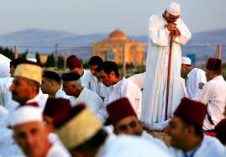
Document 2: Samaritans
The Samaritans adopted many of the Israelites religious beliefs. They worshipped the God of Israel, read the Torah, and followed the Israelites’ religious laws. The Samaritans, however, adopted religious practices that the Israelites did not accept. In time the Samaritans and the people of Israel had little in common. The Israelite faith was not continued. Today, Judaism developed from the religious faith that developed in the kingdom of Judah, not Israel.
Today Samaritans still live in the land of Israel. They use to have a population of over a million before the Roman Empire took over the land of Israel. As of 2014 the population of Samaritans was only 751. It is most likely that the Samaritans will not be able to continue because they have such a small population and do not allow people to convert (or change faith) to become a Samaritan.

1) Which of the following isn’t one of the ways the Samaritans were similar to the Israelites?
a. they worshiped the Hebrew God
b. they worshiped many gods
c. they read the Torah
d. they followed the Ten Commandments

2) Why did the Samaritans and Israelites start to break apart?

Claim
Evidence

Word Bank: Samaritans Fear Culture Assyrian Tribute Weak Move Two
After the death of Solomon Israel split into __________________kingdoms, Israel and Judah.
Splitting into two kingdoms made the Israelites _________________ and vulnerable to
attack. The Assyrians were spreading _______________ through the entire region. The
Assyrians forced the people they conquered to pay _____________. If the people refused
then the Assyrians would destroy towns and ransack cities of all valuable goods. The Assyrians also forced the people to _________________ to different areas. The Assyrians forced some Israelites to move to the ______________Empire and moved people from Assyria to Israel. A new mixed _________________ began to develop, these people were called the ________________.

Directions: Place numbers in the boxes in order to decide which event came first. Number 1 has been done for you.

 |  | 1
Some Israelites were forced to move to Assyria while some Assyrians moved to Israel | The culture of Samaritans developed | The Israelites split into 2 kingdoms, Judah and Israel | The Assyrians took over Israel | The Israelites refused to pay tribute

Directions: Draw a line to match the correct picture with the correct description.

The Israelites divide into two kingdoms: Israel and Judah

A new culture develops when the Assyrians and Israelites mix called the Samaritans

The Hebrews refuse to pay tribute.

The Assyrian Empire takes over Israel and forces Israelites to relocate to Assyria and Assyrians to relocate to Israel.

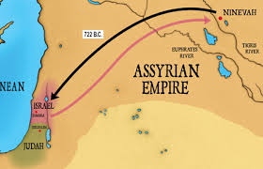

Independent Practice

Bonus: Why did Israel fall?

Answer the question above with three reasons from our lesson today. Be prepared to provide textual evidence to support your reasons!

Claim: Israel fell because (1)________________________________________________________________________,
(2)________________________________________________________________________, and
(3)________________________________________________________________________.

Rewrite your claim as one complete sentence here:_____________________________________________
________________________________________________________________________________________________________________________________________________________________________________________________________________

Reason 1 | Text Evidence 1
Reason 2 | Text Evidence 2
Reason 3 | Text Evidence 3

Name: Student #:
Date: HR:
Three Kings Foldable Rubric

 | 3 | 2 | 1
Claims | I have 3 original claims (one for each king) in which I have flipped the question. | I have 3 original claims in which I didn’t flip the question.  I have 2 original claims in which I have flipped the question. | I have fewer than 3 original claims in which I didn’t flip the question.  I have 1 original claim in which I have flipped the question.
Evidence | I have 3 pieces of evidence cited properly. | I have 3 pieces of evidence cited improperly.  I have 2 pieces of evidence cited properly. | I have fewer than 3 pieces of evidence cited improperly.  I have 1 piece of evidence cited properly.
Illustration | I have 3 illustrations with color. | I have 3 illustrations without color.  I have 2 illustrations with color. | I have fewer than 3 illustrations without color.  I have 1 illustration with color.

_________/9 Points Total

